Demo Worksheet
- Prediction/Hypothesis: Before the demo, briefly describe what you think will happen when water is added to the model. This is a model that we are going to use to investigate the behavior of water.

- Observations: Closely observe the demonstration. Then use a blue or red colored pencil to sketch in the diagram below what you observed.
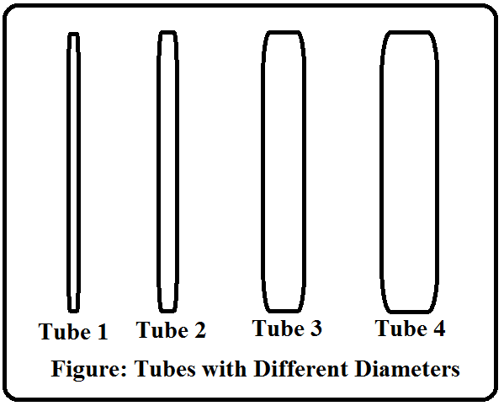

- In your own words, describe what happened to the water in the four tubes when the water was added to the demonstrator. Provide a logical explanation for your observations.

- Based on your experiences, where do you see this phenomenon occur in real life? Give as many examples as you can.

- What is the scientific term used to describe this phenomenon? What do you know about this process?

