Law of Cooling Worksheet Example Answers
Your prediction: answers will vary
Definitions
- Temperature is how hot or cold something is.
- Energy transferred from one body to another due to a temperature difference is called heat.
Background
The transfer of heat from a body with high temperature to a body with lower temperature is what runs your car’s engine and keeps food cold in your refrigerator. Let’s investigate how heat moves in time.
Equipment
- BASIC Stamp 2 with temperature probe
- 100 ml beaker of room temperature water
- ice water bath
- hot water bath
Procedure
Place temperature probe in beaker with room temperature water. Begin recording its temperature with the temperature probe. Record its temperature every 15 seconds for 5 minutes.
 | Time (seconds) | Temperature (°C) |  | Time (seconds) | Temperature (°C)
Ice Water Bath | 0 | 25 |  | 165 | 2
Ice Water Bath | 15 | 19 |  | 180 | 2
Ice Water Bath | 30 | 15 |  | 195 | 2
Ice Water Bath | 45 | 12 |  | 210 | 1
Ice Water Bath | 60 | 9 |  | 225 | 1
Ice Water Bath | 75 | 7 |  | 240 | 1
Ice Water Bath | 90 | 6 |  | 255 | 1
Ice Water Bath | 105 | 5 |  | 270 | 1
Ice Water Bath | 120 | 4 |  | 285 | 1
Ice Water Bath | 135 | 3 |  | 300 | 1
Ice Water Bath | 150 | 3

 | Time (seconds) | Temperature (°C) |  | Time (seconds) | Temperature (°C)
Hot Water Bath | 0 | 27 |  | 165 | 72
Hot Water Bath | 15 | 37 |  | 180 | 73
Hot Water Bath | 30 | 45 |  | 195 | 73
Hot Water Bath | 45 | 52 |  | 210 | 74
Hot Water Bath | 60 | 57 |  | 225 | 74
Hot Water Bath | 75 | 61 |  | 240 | 74
Hot Water Bath | 90 | 64 |  | 255 | 75
Hot Water Bath | 105 | 66 |  | 270 | 75
Hot Water Bath | 120 | 68 |  | 285 | 75
Hot Water Bath | 135 | 69 |  | 300 | 75
Hot Water Bath | 150 | 71
Analysis
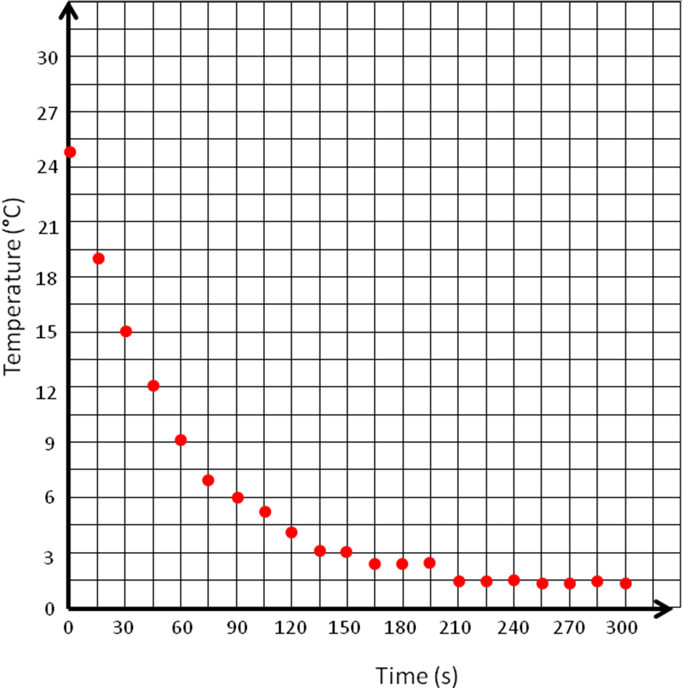
Plot your results on the graph below. Example graph for ice water bath. ⬇

Example graph for hot water bath. ⬇
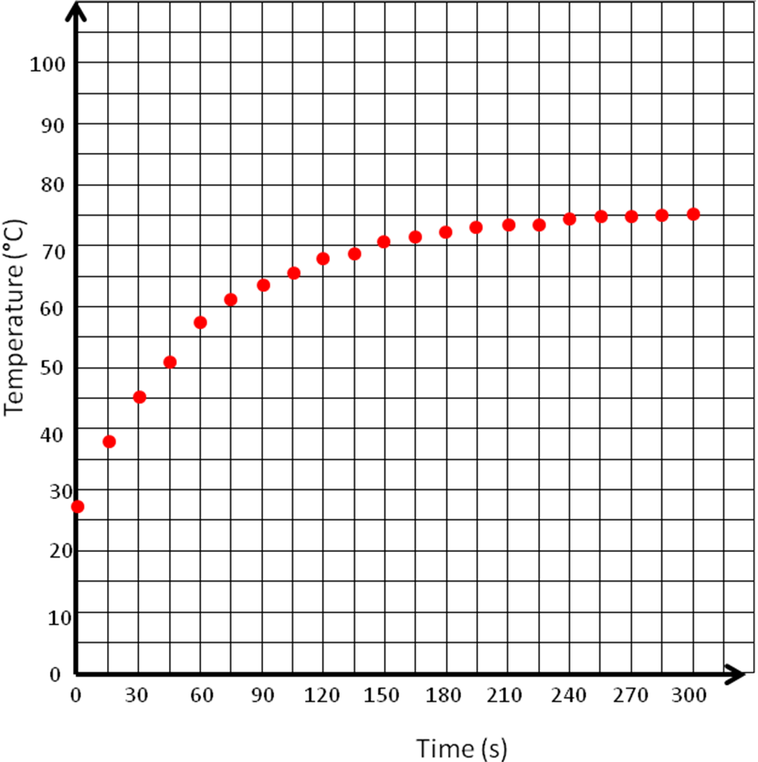

Questions
- What do you expect the temperature to be at 360 seconds? At 900 seconds?
Example good answer: For the ice water bath, expect students to predict 1 °C and 5 °C. For the hot water bath, expect students to predict 75 °C and 70 °C. The temperatures at 900 seconds reflect the interaction of the water bath with the ambient temperature of the room.

- Will the water in the beaker ever be 0º Celsius? Why?
Example good answer: No, because both the room and the sample water start out warm. As the ice water bath cools the sample water, the sample water and the room temperature heat up the water bath.

- You are an industrial engineer designing a factory to make cookies. You need to design a process to add melted butter to eggs, but you do not want the hot butter to cook the eggs. Butter starts to melt and eggs start to cook around at ~95 ºFahrenheit, so if you add a lot of melted butter to the eggs, their temperature rises and they will cook before they make it to the cookie dough! As an engineer, apply what you learned to come up with a solution for your client.
Describe a general idea for how to add a gallon of butter to a gallon of eggs without the eggs getting too hot. What kind of sensors would you need in the system to make sure the eggs did not cook from the butter? (Write approximately one paragraph.)
Example good answer: We need the eggs to be less than 95 ºFahrenheit and the butter to be more than 95 ºF, so that the butter is liquid and the eggs are uncooked. To solve this problem, we can add a little hot butter to a large amount of eggs, which only heats up the eggs a little. Then, we can stir the egg-butter mixture until the air in the room brings the temperature of the eggs back down to room temperature. At this point, the butter is spread out in the eggs, so it will not solidify into a big bunch of butter. We can repeat this process over and over until all the butter is incorporated into the eggs. Then the eggs will not be cooked and will be mixed into a homogeneous liquid mixture with the butter.

- Describe two other possible situations in which engineers might apply their understanding of heat transfer.
Example good answers: Deciding on the location of fans in a computer so the circuits do not melt. Designing the outside of the space shuttle so that it can safely re-enter the Earth’s atmosphere at high speeds (composite tiles).

