**Elevator Building Guide**

1. 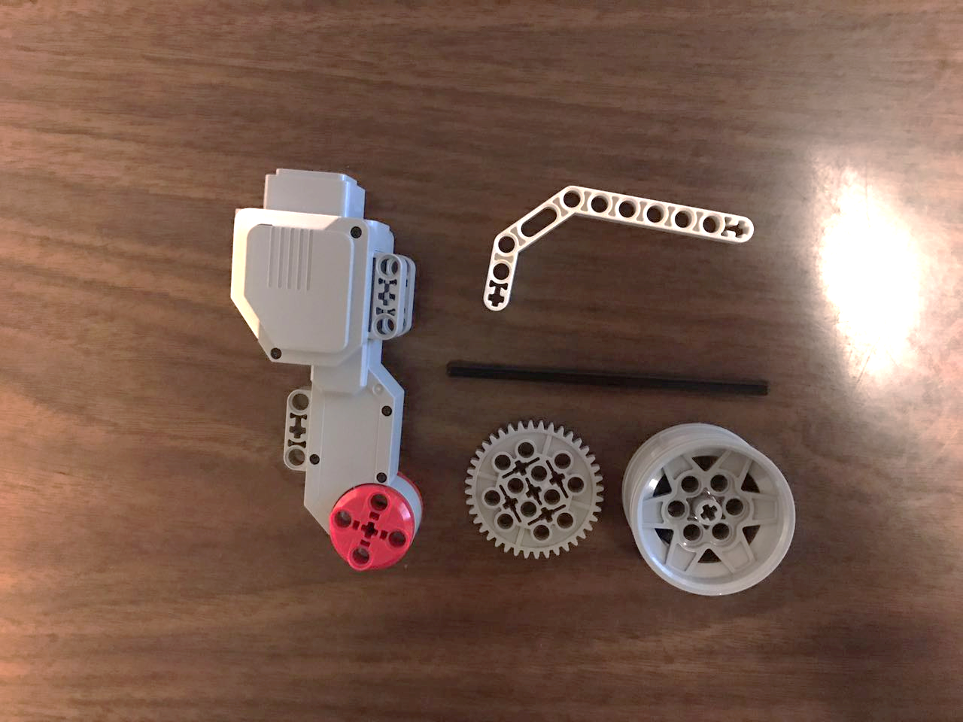To construct the elevator motor, obtain the following LEGO pieces.
2. 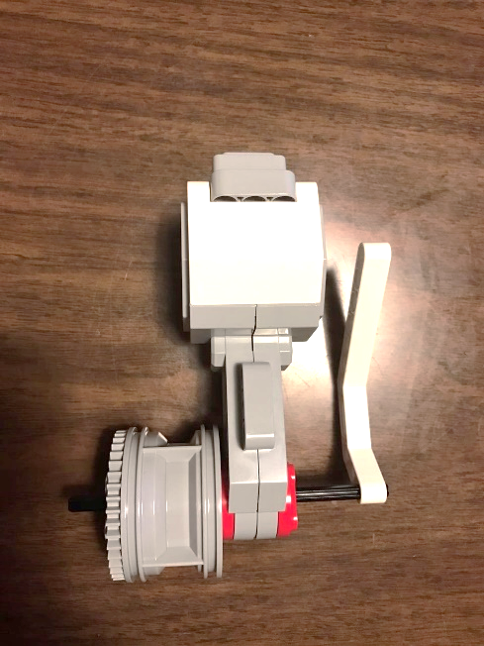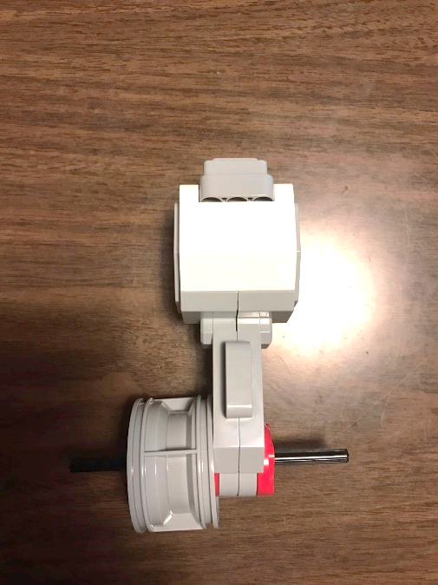Build using the LEGO pieces.

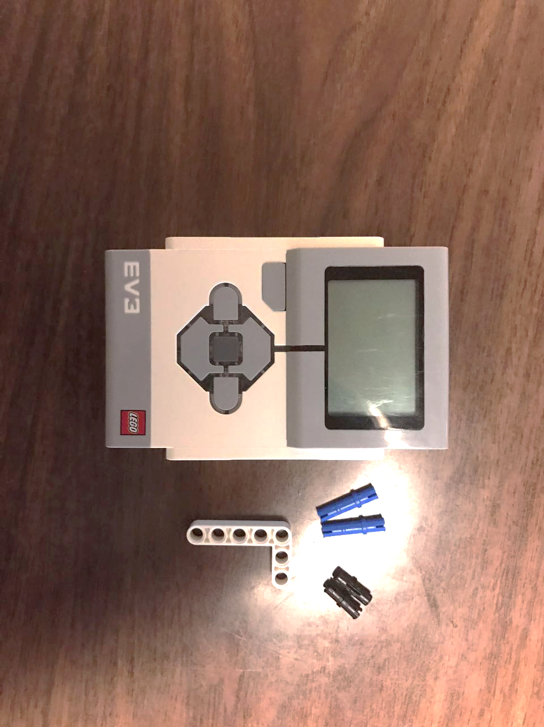

1. To create a mount for the elevator motor, obtain the following pieces.

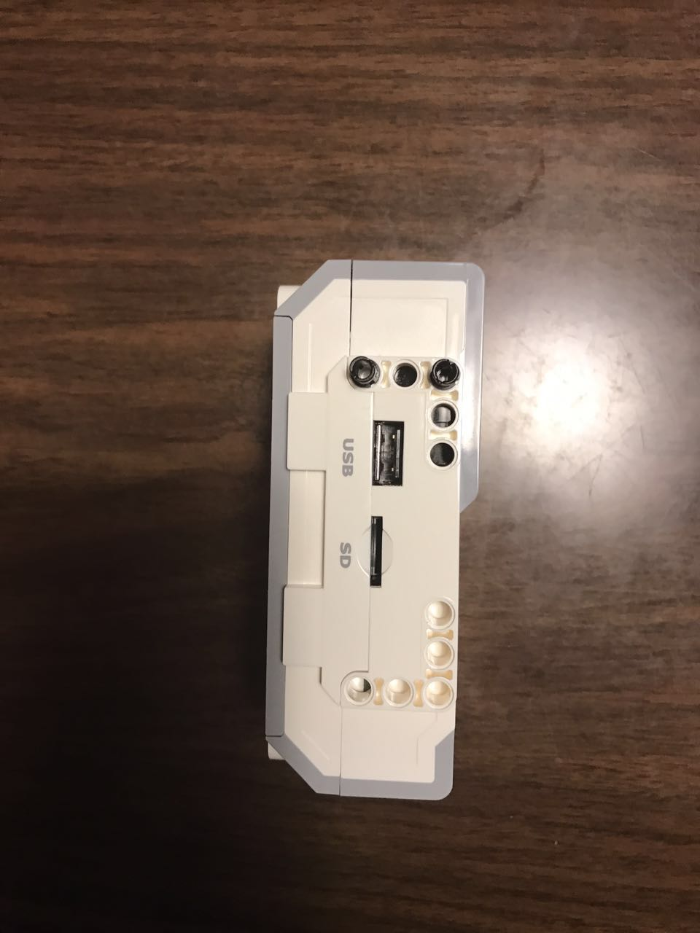

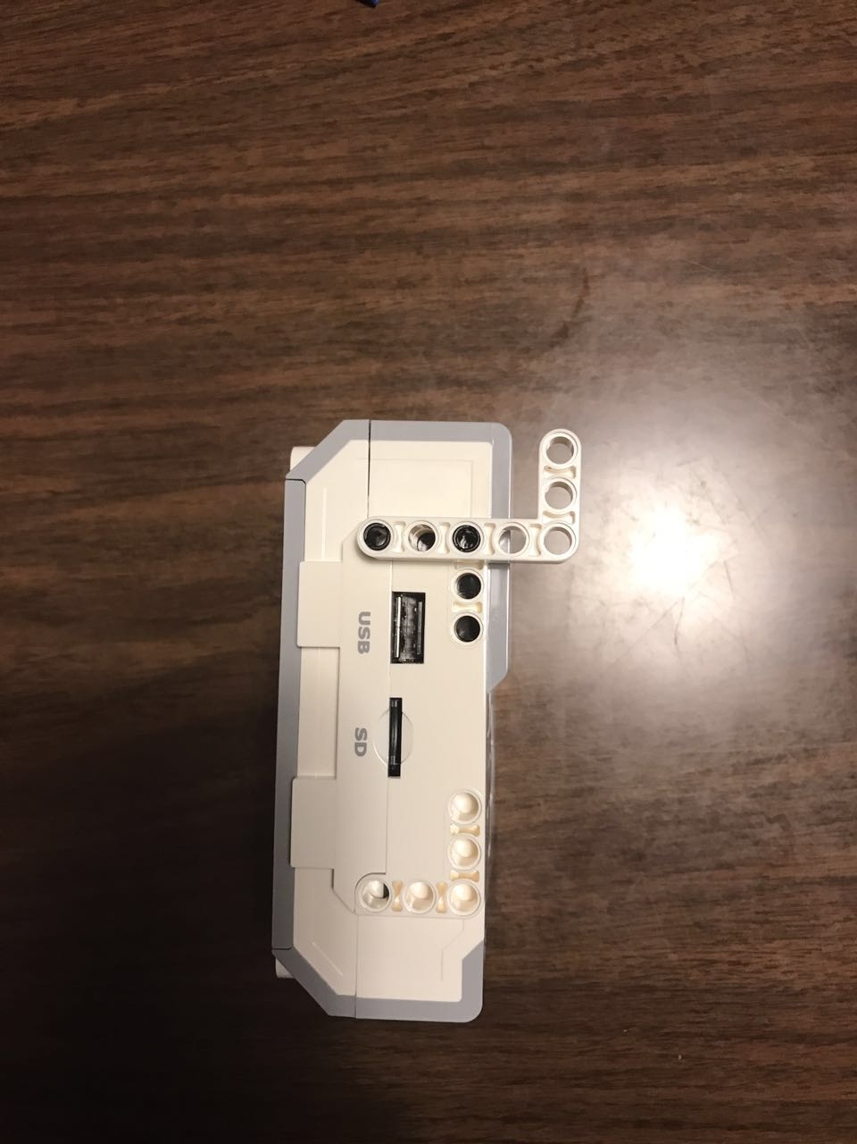

1. Build using the LEGO pieces.
2. 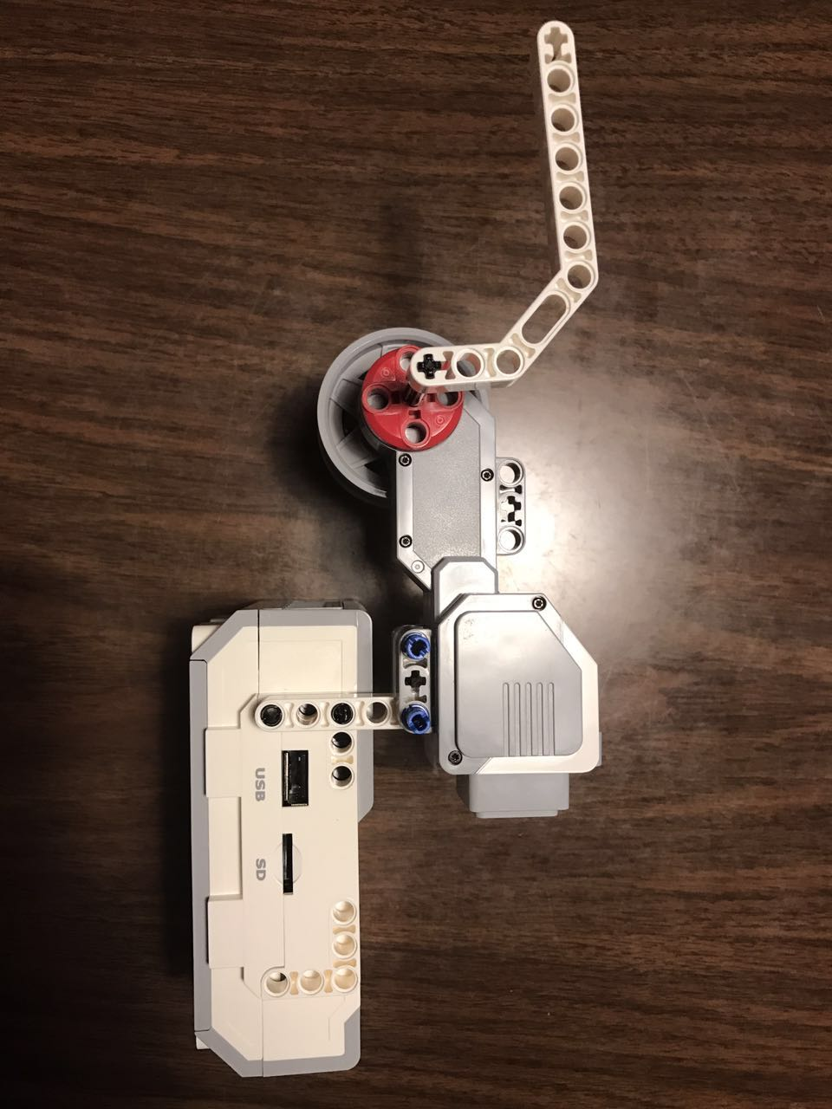Attach your motor, as shown, using the LEGO pieces.
3. 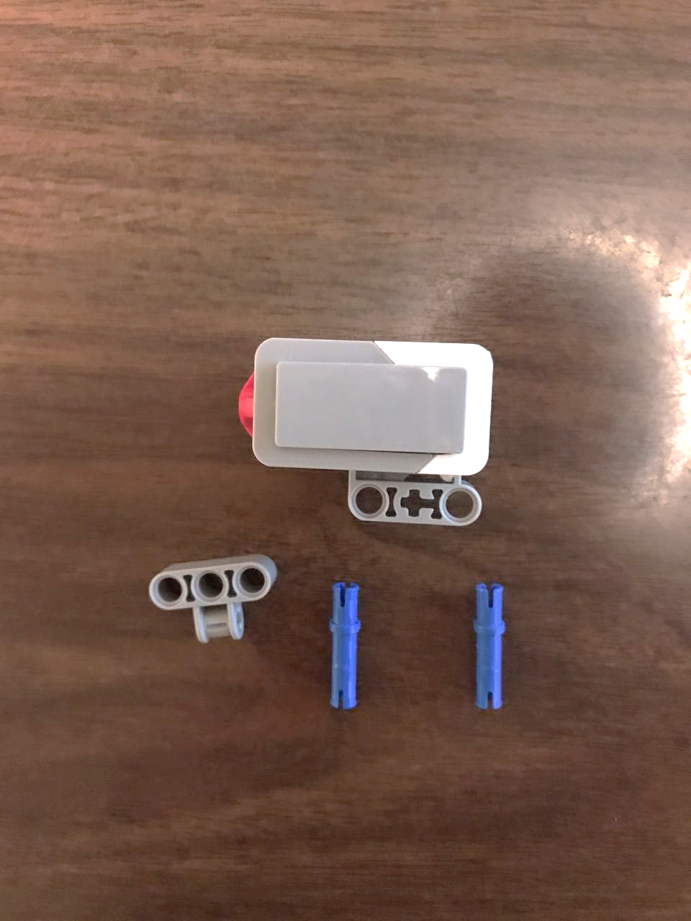To construct the elevator button from a touch sensor, obtain the following LEGO pieces.

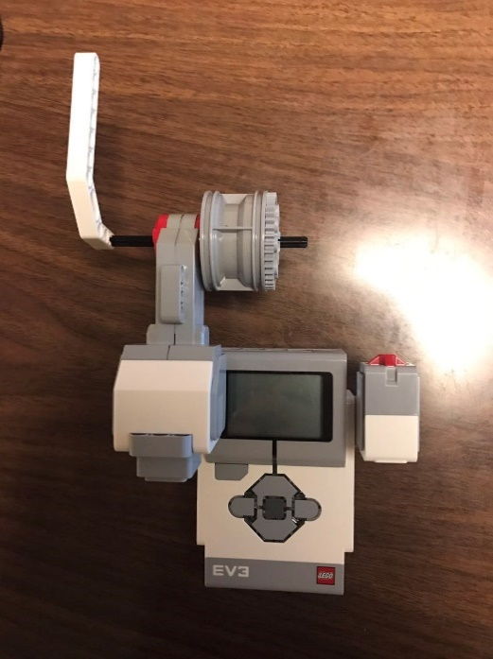

1. Build using the LEGO pieces.

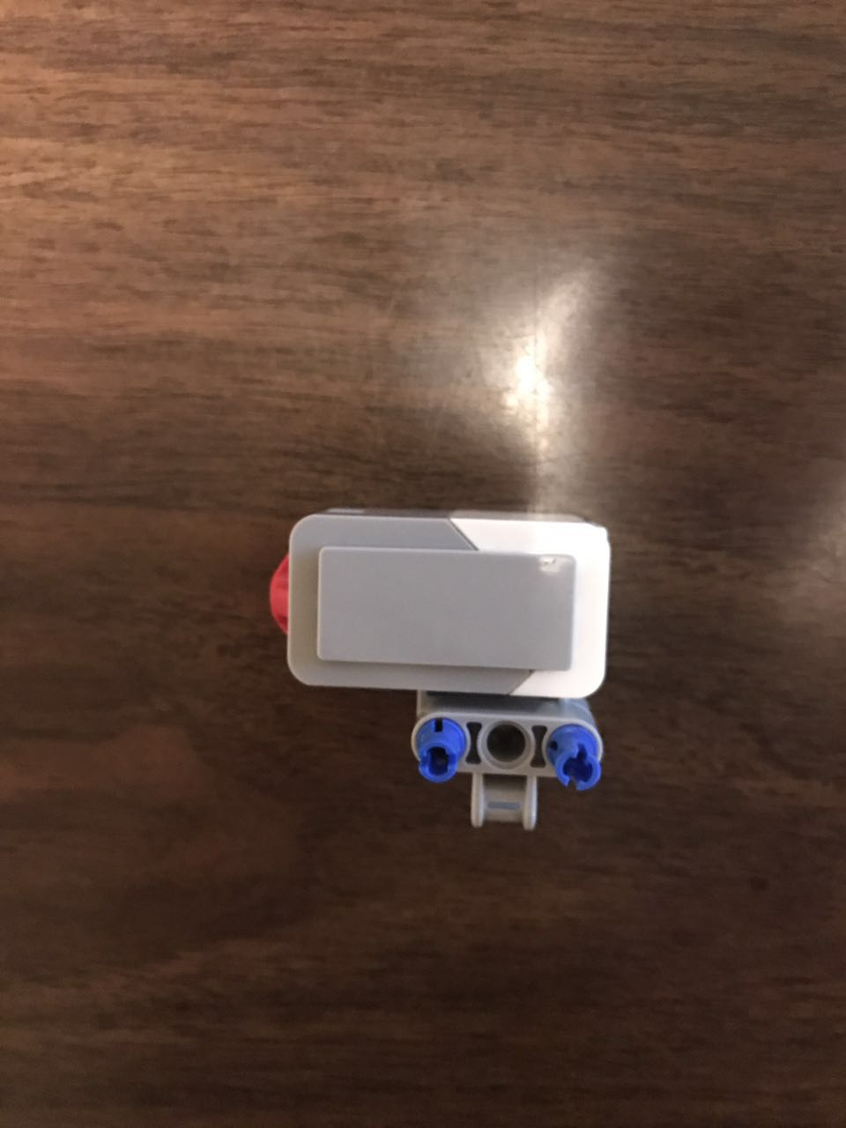

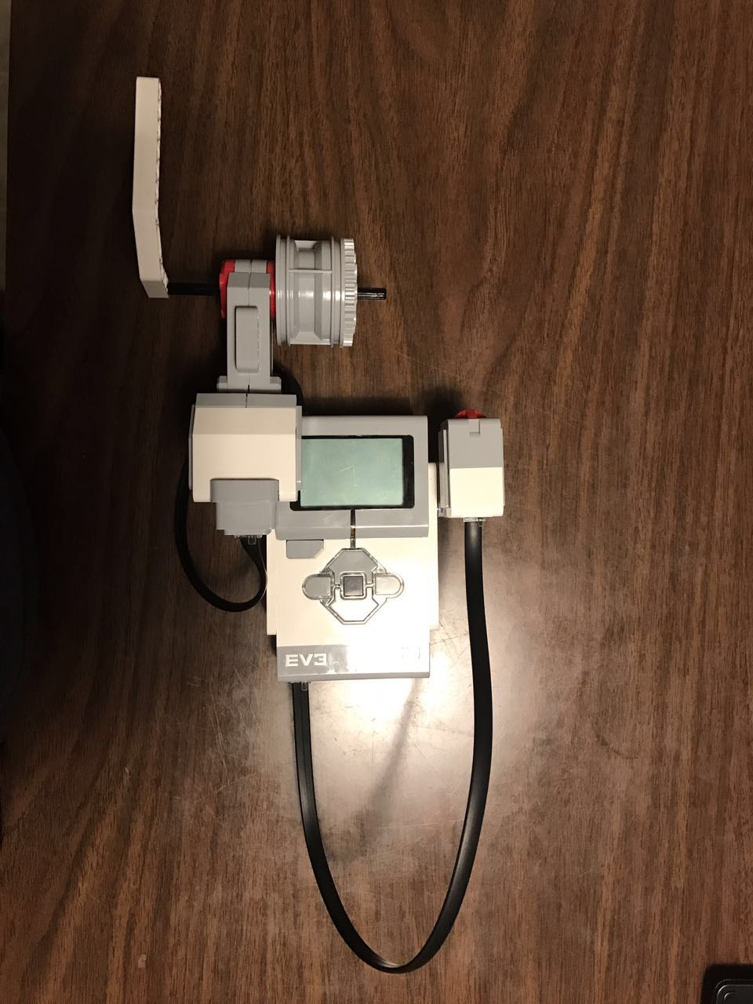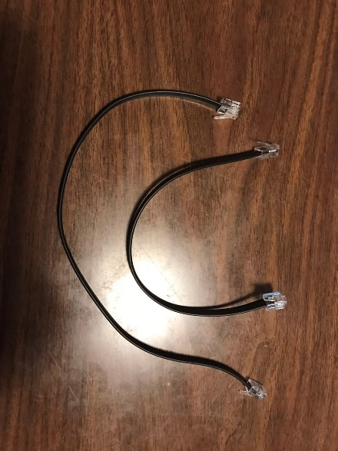

1. Attach the cables to the sensor (use port 1) and motor (use port A).
2. 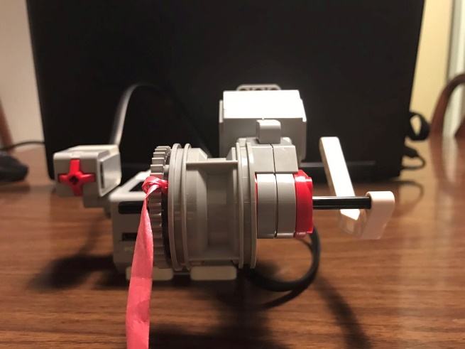Attach your designed elevator box and cable to the gear, as shown below.
3. Use the handle on the motor to move the elevator up and down.

