Elevator RobotC Programming Guide
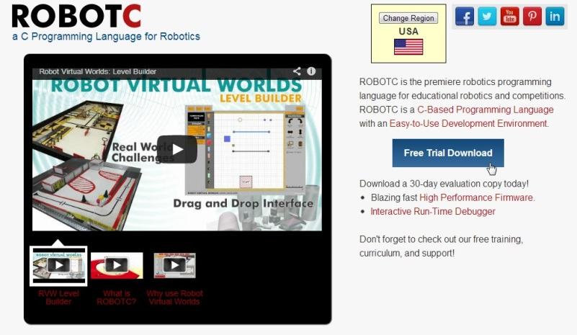
- Download the free trial RobotC programming language for LEGO EV3 at www.robotc.net.

- Follow the instructions to install RobotC.
- Open RobotC.

- Activate the free trial license by going to Help > Manage License > Add License.
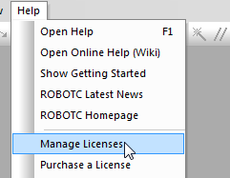

- Select Product > ROBOTC for LEGO MINDSTORMS > Start Trial > Yes > Close > Close.
- Click on Robot > Compiler Target > Physical Robot.
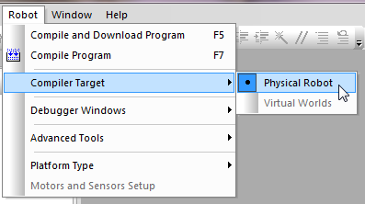

- Open the supplied file by going to File > Open and Compile > “pick the file from saved location” > elevator.c > Open

- Connect the LEGO EV3 to the computer with a USB cable.
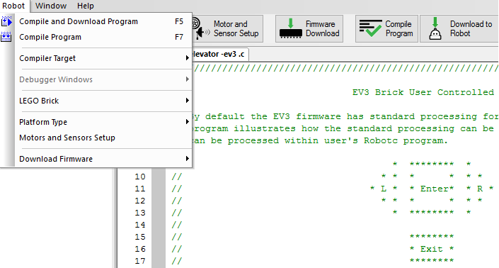
- In RobotC, download the supplied program into the Lego EV3 brick.

- The device is now ready to be used.

