Example Robot Line-Follow Program
Below is an example program that can be used to make an NXT LEGO robot follow a dark line on a light background. The “Overview” visualization illustrates the completed NXT 2.0 program, which can be assembled using NXT 2.0 software (included with any LEGO MINDSTORMS NXT 2.0 robot kit) by sequentially adding the individual blocks displayed under “Block Details.”
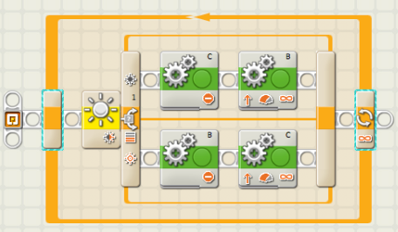
Overview

Block Details
