Foucault Pendulum Worksheet Answers
- Before using the experimental setup: What do you think the motion of an object viewed from a rotating platform will look like?
If the object is not moving, it will be a circle; otherwise, it will be a more complex shape such as spirals.

- Now using the experimental setup: What do you think the motion of the pendulum bob will look like when the platform that the camera is mounted on is not rotating? Describe and illustrate your response.
The motion of the pendulum projected on a piece of paper lying on the floor is a straight line.

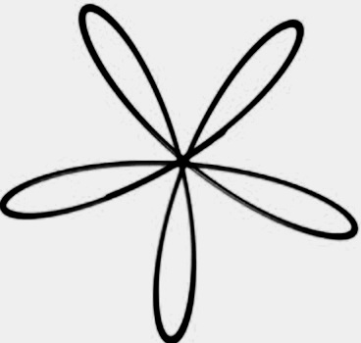
- Now that the platform is rotating: What do you think the motion will look like? Illustrate your response below by a graph. Also if the speed was increased, what would you observe?
The motion of the pendulum projected on a piece of paper lying on the floor is a succession of spirals with a common center of the pendulum stationary point (as shown to the right ).
When the platform speed is decreased, the number of spirals increases, and vice versa.

