Friction Force Pre-Assessment ANSWER KEY
- Define friction:
Friction is a force that causes change in motion. This is because friction opposes the relative motion of surfaces in contact.

- When you slide a book along a table, does friction make the book go faster or slower?
Friction makes the book go slower because it opposes the motion of the book. In fact, the book will eventually come to a stop due to friction.

- The block below is sliding to the right on a table. Which way does the force of friction act?
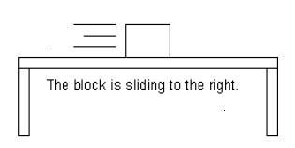
The friction force acts to the left so that it slows the block down.

- Which of the following has a GREATER friction force (circle on):
  - Riding a bike on tile floors.
  - Riding a bike outside on grass.

- Why do you think engineers would design car tires to have a rubber coating?
Engineers design tires to have a rubber coating to increase the traction or grip between the surface of the tire and the surface of the road. Especially on wet, icy or snowy roads, it is important to have good traction so that the wheels roll and do not slip.

- Did working with robotics help you understand friction? Please explain.
Answers will vary depending on students’ opinions.

