Friction Force Pre-Assessment
- Define friction:

- When you slide a book along the table, does friction make the book go faster or slower?

- The block below is sliding to the right on a table. In which direction does the friction force act?
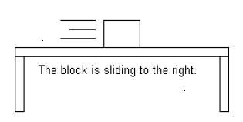

- Which of the following scenarios has a GREATER friction force (circle one):
  - Riding a bike on tile flooring.
  - Riding a bike outside on the grass.

