Gears Pre-Assessment Survey
A Wheel is connected to smaller gear on the left.
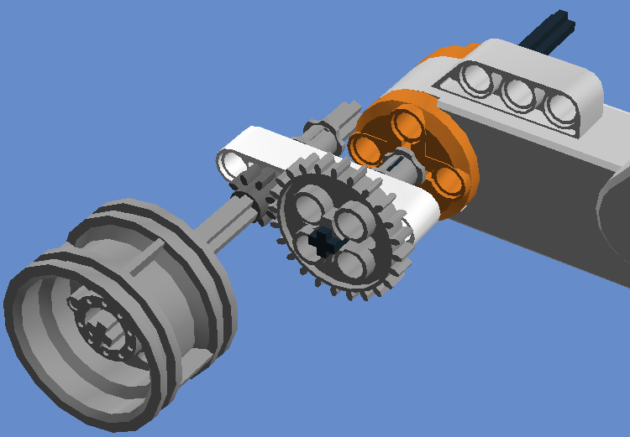
B Wheel is connected to larger gear on the left.
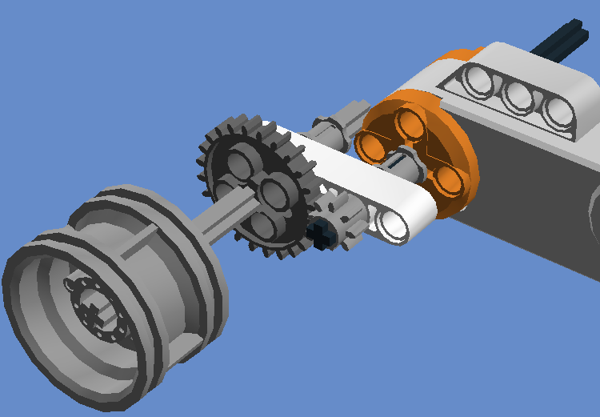
- Describe 2 uses of gears?

- In the figure on the right, which setup with gears will make the wheel turn faster? If you are not sure, write C.

- In the figure on the right, which setup with gears will make the wheel move more weight? If you are not sure, write C.

- What is the speed of a car that travels 10 miles in 2 hours? How did you get your answer?

