Building Guide for Modified Gear Set
Follow the steps below as a guide to make your own gear box with different gear ratios to use in your experiment.
- Collect the LEGO pieces shown below.
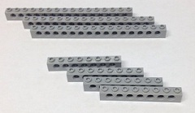

2. Place two shorter pieces as shown below.

3. Place the long bars onto the pieces.
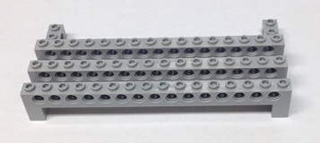

4. Place the other two short bars onto the horizontal bars.
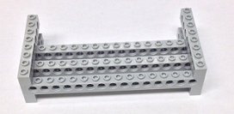

5. Make two of the part seen in step 4.
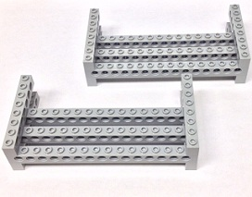

6. Find four black pegs to connect the two pieces.
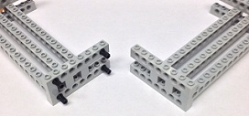

7. Connect the two pieces so it looks like this.
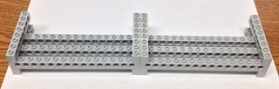

8. Collect the LEGO pieces shown below.
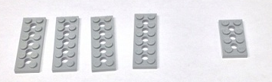

9. Connect the pieces like this.
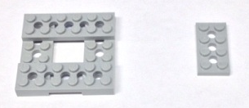

10. Connect them to support the base.
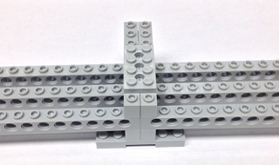

11. Collect the LEGO pieces shown below.

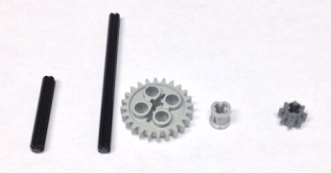

12. Connect the pieces to make the left gear chain.
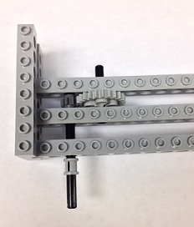

13. Collect the LEGO pieces shown below.
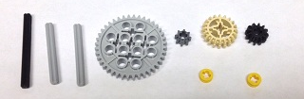

14. Connect the pieces to make the right gear chain.
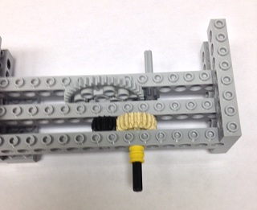

15. Add on the pulley wheels.
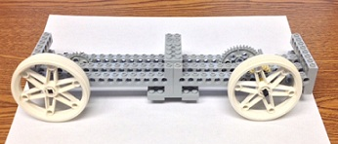

16. Collect the LEGO pieces shown below.

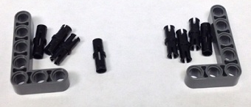

17. Connect the pieces like this.

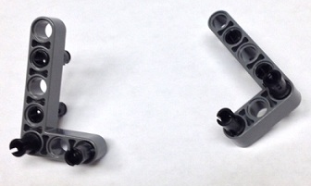

18. Connect them to servomotors.
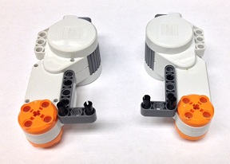

19. Connect the motors to the rest of the assembly.

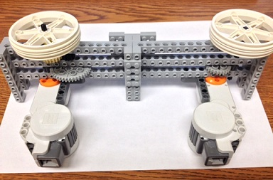

Below are pictures of another model of the same experiment:
- Top view of first gearset. The pulley will be mounted on the black shaft, touching the yellow spacer.
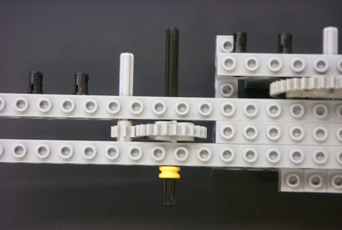

- Top view of second gearset. The second pulley will be mounted on the black shaft, against the yellow spacer. Note that the right-most shaft plays no role in this gearset.

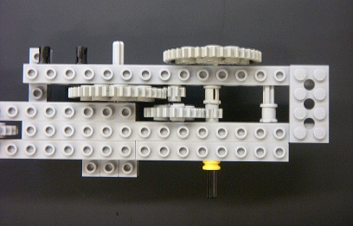

- Top view of both gearsets, with black links for motor attachment points.

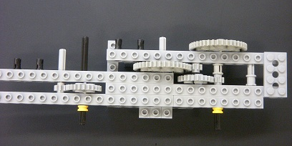

- Back view of both gearsets. This is the side to which the motors will be attached. The first motor attaches to the the gray shaft on the left, while the second motor attaches to the gray shaft on the right.

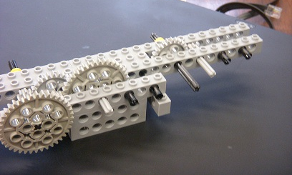

- Attach the shown L-shaped pieces to the black connectors mentioned previously.
These pieces serve as motor mounts.
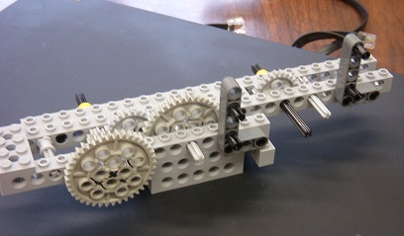

- Attach the motors to the shafts specified above, snapping them in to the black connectors.
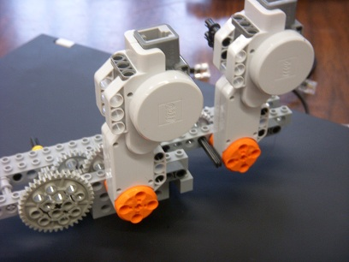

- Attach the large white wheels (to be used as pulleys) to the shafts mentioned above.
Tie a string around each wheel. The setup is now complete.
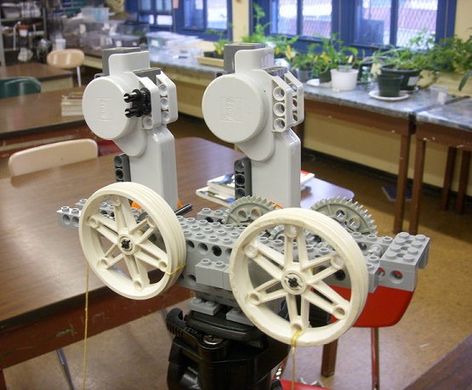

- Find a suitable surface to mount the mechanism on. A tripod works nicely for demonstrations, while a table or desk edge also works well.

