**Engineering Challenge Worksheet Example Answers**

**Engineering Challenge:** *Design a gear set that will lift the provided weight the fastest*. From what we’ve observed in the demonstration, we know that a large gear attached to the motor and a smaller gear being driven can lift light objects very quickly, but suffers when trying to lift heavy objects. Conversely, a small gear on the motor and a large gear being driven lifts very slowly, but can lift very heavy objects.

1. First, **design your gear set**. From the chart below, choose which gears you will use, and indicate which one will be attached to the motor, and which will be driven.

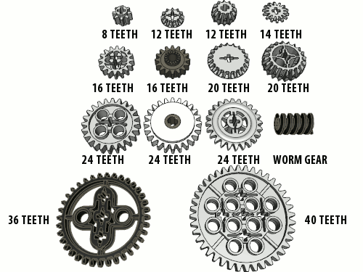

*Note:* The **best gear ratio for this activity** is the 8-tooth gear attached to the motor and the 40-tooth gear driven by the motor, with a gear ratio of 1:5.

The gear ratio answer provided on this page is an example student answer, which allows for more useful example answers to the subsequent questions.

Also, the time to pull up the weight may vary between setups if the length of string used is different than 2 feet.

**Attached to motor (driver gear): ______16_teeth______**

**Driven by motor: ______40_teeth______**

**Gear ratio: ______16:40 = 2:5_______**

**Time to lift binder weight: ______7.7 seconds________**

1. Next, implement your design and write a short performance summary. *If you were to revise your design, what would you change and why?*

*Example answer*: I would change our design so that a smaller gear is on the motor.

1. Visit other groups and inspect their designs. *How do your classmates’ designs compare to yours?*

*Example answer*: To pull up the nuts, the design with the 8-tooth gear works better than the 16-tooth design.