**A LEGO® Introduction to Graphing Activity –   
Ball Shooter Graphing Worksheet – Answers**

**Instructions**

As shown in the image below, you will be working with a LEGO® MINDSTORMS® EV3 ball shooter. You will be adjusting the power level of the EV3 motor through a wired remote with touch sensors, which will be used as buttons.

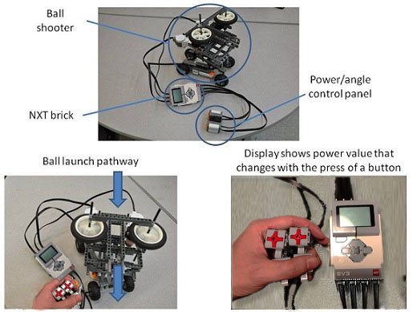For this activity, you will only need to use the buttons that adjust the speed of the motors. The ball also must be inserted by hand through the back of the robot, as shown below.

EV3 bricks

**Data Collection Table**

For each of five trials, record the distance the ball travelled and the power setting for each launch in the (sample) data table below.

|  |  |
| --- | --- |
| **Distance the ball travels (Y),  in inches** | **EV3 Power level (X)** |
| 10 | 51 |
| 13 | 63 |
| 17 | 72 |
| 21 | 81 |
| 27 | 90 |
| 32 | 100 |

**Graphing Exercise**

On the grid below, label reach set of axes according to the collected data. Then, on the appropriate axes, plot the recorded data and draw a line through each point in order. Use a different colored pencil for your line.

Sample Graph (from Sample Table, above)

