Measuring g Activity Worksheet

Do Now: Vocabulary
Gravity is ___________________________________________
_____________________________________________________.
Velocity is___________________________________________
________________________________________________.
Acceleration is _______________________________________
________________________________________________.

Lesson: The acceleration due to gravity is constant on all objects, regardless of mass or weight. It equals
g = 9.8 m/s²

We can calculate this number by measuring the time for a ball to fall from a measured height, and using the formula

v = (g/2) t
where
- v is the average velocity of the ball
- t is the time for the ball to fall
- g is the constant of gravity

This is the equation of a ___________, with slope equal to _____________.

Experiment:
Equipment:
- Lego NXT brick, motor, and touch sensor in “release setup”
- Meter stick

Procedure: Using the experimental setup, release the ball from different heights and record the time it takes for the ball to hit the base plate. This time will be displayed on the LEGO NXT brick, in seconds. Calculate the average velocity of reach drop height using the formula:
v = height /time

Record data here.

Data point | height | time | average velocity  (height / time)
Example | 4 m | 5 s | 4 m/5 s = 0.8 m/s
1 | 0.25 m
2 | 0.5 m
3 | 0.75 m
4 | 1 m
5 | 1.5 m
Analysis: Plot your data points (time, average velocity) on the graph below. Don’t forget to label the axes.

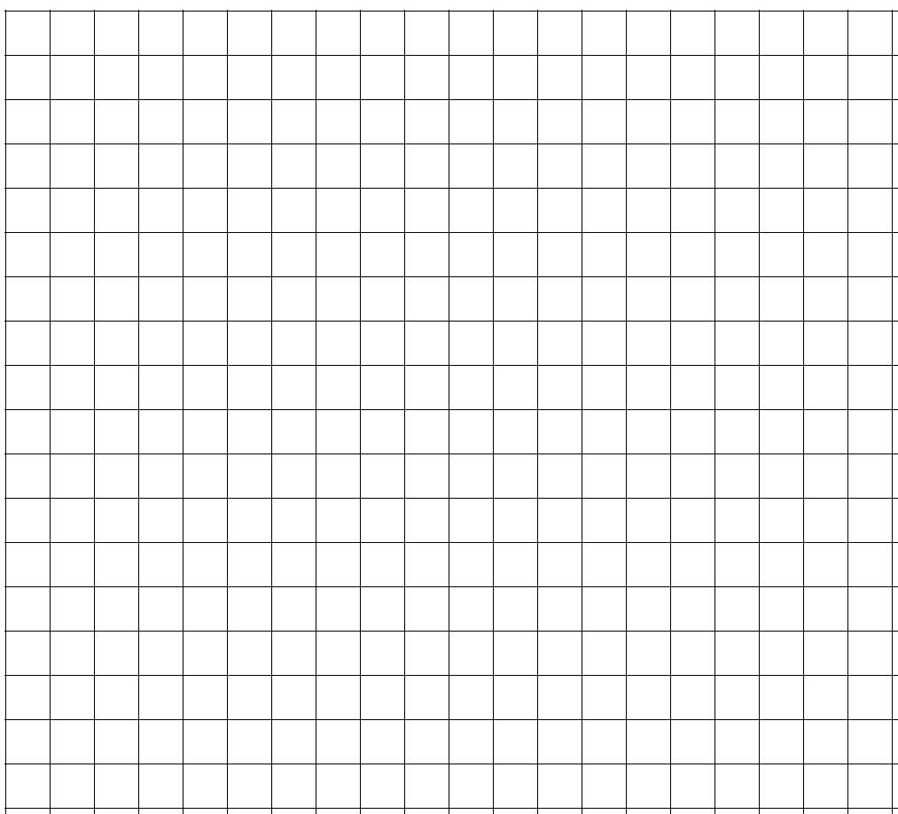
average velocity (ft/s)
0 0.25 0.5 0.75 1

time (s)

Plot your data points (time, average velocity) again, using a spreadsheet program (e.g. Microsoft excel). Add a best fit line to your data (linear regression or trend line) in excel) and generate an equation, as well as the R² value for this line.

Equation of best fit line (y=mx +b): _______________________

The slope of the best fit line is :_______ ft/s²

Question: How does the slope of your best fit line compare to the standard value of g?

Question: What are possible explanations for the difference in the values for the measured acceleration due to gravity (the g value you calculated through today’s experimental measurements) and the accepted value of g?

Question: For some engineering designs, it is crucial for the engineers to know the exact value of g. Can you think of some examples of engineering designs and applications for which this would be true?

