Milk Race: Investigating Viscosity

What kind of milk do you drink? Do you notice that certain types of milk have a thicker texture than others? If so, do you think that contributes to how fast it flows out of a container? In this lab, we’re going to investigate how fast different types of milk flow and the reasons why.

Let’s define viscosity:

Viscosity: ____________________________________________________
___________________________________________________________

Your group will need:
- column
- prepared samples of milk in test tubes
- funnel or pipette
- timer
- beaker/bowl

Procedure:
1. Break into groups (2-4 students) and collect test tubes of milk samples consisting of one known/control sample (whole milk) and four unknown samples (skim milk, 1% milk, 2% milk, and heavy cream).
2. Using a funnel or pipette, pour the first sample (whole milk) through the capped column.
3. When ready, un-cap the column, start the timer, and count the number of drops that drip out of the column over a one minute period. Record the number in the chart below.
4. Repeat step 3 three times to obtain an average # of drops/min (flowrate).
5. Repeat steps 2-4 for the unknown samples.
6. Graph the flowrate [drops/min] of each sample on the graph provided.
7. Using your graph, order the test tubes from highest flowrate to lowest flowrate.

Table 1: Record your number of drops here for each trial. Use this table to then calculate the average flowrate of all samples.
 | Identification | Flowrate 1 | Flowrate 2 | Flowrate 3 | Average Flowrate
Control | Whole Milk
Unknown 1
Unknown 2
Unknown 3
Unknown 4

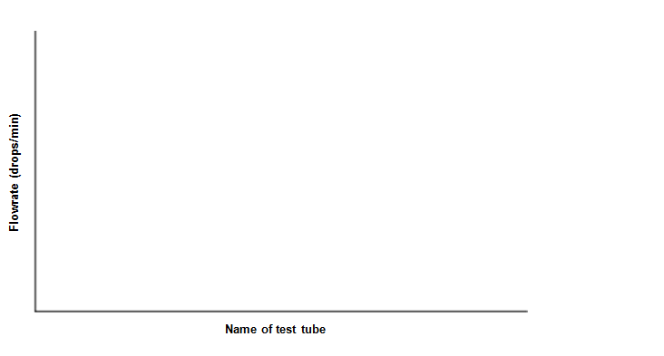

Graph 1: Using the average flowrate value, graph the data for all samples.

Answer the following questions in complete sentences:
1. What are the dependent and independent variables in this experiment?

2. How were you able to identify the unknown solutions?

- Was your hypothesis correct?

- What can you say about the relationship between viscosity and the flowrate of a liquid?

5. What do properties like viscosity and flowrate have to do with the chemistry of a particular fluid? How do different concentrations of fat in milk/cream affect their viscosity and flowrate through a column?

6. When would scientists or engineers want to use liquids of high viscosities? Low viscosities?

