Milk Race: Investigating Viscosity Answer Key

What kind of milk do you drink? Do you notice that certain types of milk have a thicker texture than others? If so, do you think that contributes to how fast it flows out of a container? In this lab, we’re going to investigate how fast different types of milk flow and the reasons why.

Let’s define viscosity:

Viscosity: Viscosity is a measure of a fluid’s resistance to flow. It describes the internal friction of a moving fluid.

Your group will need:
- column
- prepared samples of milk in test tubes
- funnel or pipette
- timer
- beaker/bowl

Procedure:
1. Break into groups (2-4 students) and collect test tubes of milk samples consisting of one known/control sample (whole milk) and four unknown samples (skim milk, 1% milk, 2% milk, and heavy cream).
2. Using a funnel or pipette, pour the first sample (whole milk) through the capped column.
3. When ready, un-cap the column, start the timer, and count the number of drops that drip out of the column over a one minute period. Record the number in the chart below.
4. Repeat step 3 three times to obtain an average # of drops/min (flowrate).
5. Repeat steps 2-4 for the unknown samples.
6. Graph the flowrate [drops/min] of each sample on the graph provided.
7. Using your graph, order the test tubes from highest flowrate to lowest flowrate.

Table 1: Record your number of drops here for each trial. Use this table to then calculate the average flowrate of all samples.
 | Identification | Flowrate 1 | Flowrate 2 | Flowrate 3 | Average Flowrate
Control | Whole Milk
Unknown 1 | Skim Milk
Unknown 2 | 1% Milk
Unknown 3 | 2% Milk
Unknown 4 | Heavy Cream

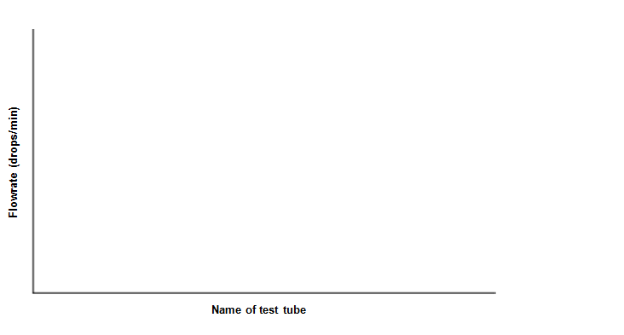

Graph 1: Using the average flowrate value, graph the data for all samples.

Answer the following questions in complete sentences:
1. What are the dependent and independent variables in this experiment?

The dependent variable is the flowrate.
The independent variable is the fat-content of the milk.

2. How were you able to identify the unknown solutions?

The higher the flowrate, the less fat present. When you arrange the solutions in order of flowrate, the highest flowrate would represent skim milk and the lowest flowrate would represent heavy cream.

- Was your hypothesis correct?

Answers vary.

- What can you say about the relationship between viscosity and the flowrate of a liquid?

The higher the flowrate, the lower the viscosity or the less viscous a liquid is.

5. What do properties like viscosity and flowrate have to do with the chemistry of a particular fluid? How do different concentrations of fat in milk/cream affect their viscosity and flowrate through a column?

The more fat-content in the milk, the harder it becomes for the liquid to flow through a column. A fluid with large viscosity resists motion because its molecular makeup gives it a lot of internal friction. A fluid with low viscosity flows easily because its molecular makeup results in very little friction when it is in motion.

6. When would scientists or engineers want to use liquids of high viscosities? Low viscosities?

Scientists or engineers would use liquids with high viscosities when they are interested in generating materials that could mimic tissue for tissue repair. Scientists or engineers may use solutions with low viscosities, when they are to make homogenous buffers or solutions for their experiments.

