Mouse Trap Racer Analysis Worksheet
Accelerometer
The acceleration sensor we are using outputs dimensionless values in the range to . To convert these values to readings in acceleration units m/sec², use the following formula
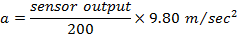
For example, suppose the accelerometer is reading a value of units. The corresponding acceleration to three significant figures
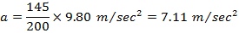
Exercise 1
In the NXT Mindstorms software, open and read the help menu for the Acceleration Sensor Block.
- How many axes are available for applications? _________
- Which axis are you using for the mouse trap racer? _________
- What wire color is used to carry number data? _________
- Draw a diagram of the way you oriented your accelerometer.

Acceleration, velocity, and displacement
The mouse trap racer starts at rest. Therefore, our initial velocity is m/sec. On launch, a torque is applied to the rear axle by the wound string attached to the mouse trap bracket. Assuming sufficient traction between the floor and wheel tires, a nonzero force is applied to the racer. According to Newton’s second law, this causes the racer to accelerate in the direction of the force. Assuming equal force, a racer of the smallest mass will have the largest acceleration, as expressed by the formula
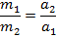
We see that the mass and acceleration ratios are inversely related.
Suppose that between the given time instants and , the racer is accelerating with constant acceleration . Acceleration can be defined as a change in velocity divided by the interval between these two time instants and
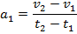
Setting and , and solving for we obtain
as the velocity at time . Next, suppose that between time instants and , the racer is accelerating with constant acceleration . Accelerations and are not necessarily equal. Therefore we have
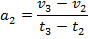
Solving for , we obtain
and substituting for , we get
Continuing in this way, we can obtain a formula for velocity at time
and so on for , , .... As the string runs out, the racer starts to decelerate due to friction forces between the axles and chassis, and acceleration becomes negative, and we should remember to figure in acceleration terms with a negative sign.
Having computed the velocity versus time from the acceleration versus time data, let us now compute displacement versus time. Velocity can be defined as the change in position divided by the time interval. For the time interval and constant velocity , we have
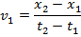
Setting and , and solving for we obtain
as the distance the racer has traveled from time zero to time . Next, suppose that between time instants and , the racer is again traveling with constant velocity . Velocities and are not necessarily equal. Therefore we have
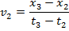
Solving for , we get
and substituting for , we get the total distance traveled at time
The distance traveled from to is similarly
and so on for , , .... Finally, since the mouse trap racer will always move forward, all velocities will be positive.
In the above, we assumed that acceleration and velocity values did not change between the given times. However, we can guess that these values do change, and in fact, change continuously between the times that accelerometer readings are taken. We therefore ask
- How can we better model the fact that acceleration and velocities change continuously and still be able to use our formulas from above?
One simple way to answer this question is to take the average of acceleration and velocity values between the reading times. For example, instead of assuming that the constant acceleration over the interval to is , we assume that this acceleration is , and similarly for the velocity values. In this way, we are able to form a better guess (or estimate) of these values. For other reading times, we form similar averages. For example, over the interval to , we will use the acceleration estimate and the velocity estimate . So given the accelerometer readings , , , … at the times , , , …, we can compute the velocity at any time by substituting acceleration average for and velocity average for in the formulas we derived above.
Exercise 2
- Derive an expression for , the velocity at time using average accelerations between each reading time (Hint: first work out the formula for up to time , and then substitute for , for to ).

- Derive an expression for , the total displacement at time using average velocities between each reading time (Hint: in your answer to first question, substitute velocity for acceleration on the right side, and displacement for velocity on the left side).

- Suppose the accelerometer readings are given in units of m/sec² as 4, 3, 2, 1, 0, -2, -1, 0. The corresponding times are given in seconds as 0, 1, 2, 3, 4, 5, 6, 7. Compute the velocity versus time and distance traveled versus time (Hint: substitute these numbers into the equations you found above).

- Now the accelerometer readings are plotted on a graph using black circles below. Notice that the area of the first rectangle with height is equal to , and so on for the other rectangles. Sketch graphs for the velocity versus time, and displacement versus time, assuming the racer is initially stationary. Use the provided empty axes.

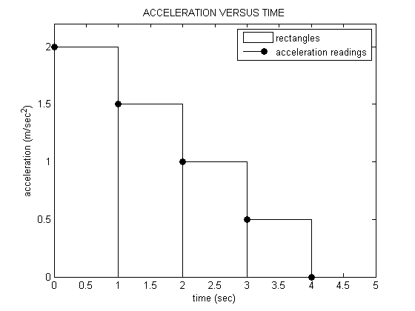
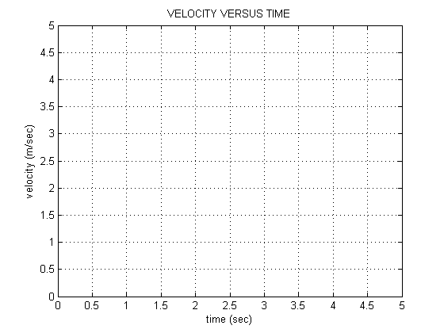

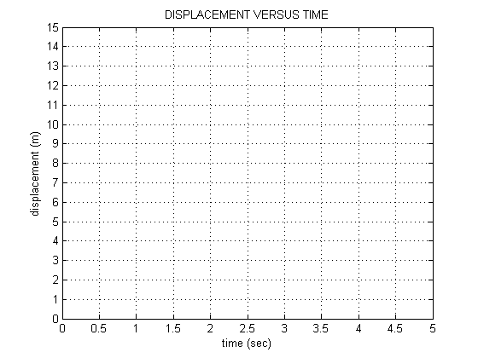
- What happens as the difference between the time instants is decreased – in other words, as we start taking readings at a larger and larger rate?

▀

