Building a Stronger (Sweeter) New Orleans Activity —
Stress vs. Strain Worksheet – Answer Key

Directions
Use the following graph to answer questions 1-7.
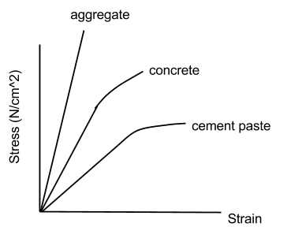
Questions
For each of the following questions, please use complete sentences and explain your answers.
- Research and explain the difference between aggregate, concrete and cement.
Aggregate – sand, crushed stone, gravel or shale
Cement – mixture of clay and limestone that is used to bind the materials together
Concrete – combination of water, aggregate in a matrix of cement
- Which of these is a composite material? Explain your answer.
A composite material is one that is made by combining at least two materials that have different properties from each other. Cement is a composite material because it combines aggregate in a matrix of cement.
- Which material has the largest value of Young's modulus? Explain.
Aggregate has the highest Young’s modulus. Young’s modulus is the slope on a stress-strain graph, and aggregate has the highest slope.
- Which is the stiffer material? Explain.
Aggregate is the stiffest material. It has the largest Young’s modulus, which means that it does not stretch a lot (strain) for large values of applied pressure (stress).

- Which of the three materials would you prefer to use for building? Explain.
I would prefer to build with concrete because it has a larger Young’s modulus than cement paste. This means it will not stretch as much as cement when force is applied to it. It is better than aggregate because it will stay together.
- The stress vs. strain curve for the cement flattens out at the end. Explain what this means.
This means that the cement stretches a lot for small increases when force is applied to it. Once the cement leaves the linear region at the beginning, it begins to deform. Even if the force applied to it is removed, it will not return to its original shape or size.
- The sample of cement that was used to generate data for the graph above was 5 mm wide and 5 mm long. Imagine that you are given a sample that is wider and longer. Will the graph of stress vs. strain be different for this sample? Explain.
No, the graph will be the same. Stress measures force per unit area, not just force. Strain measures the ratio of the length a material stretches or compresses to its original length. Therefore having a different amount of the material will not change how much strain is caused by particular values of stress. (The graph would be different if it measured force and distance stretched or compressed.)
- You are given two unknown materials, labeled A and B. Material A has a Young's modulus of 1 N/cm² and material B has a Young's modulus of 2 N/cm². Each material is initially 4 cm long.
  - Sketch a graph of stress vs. strain for the two materials on the same set of axes.

- Which material compresses more if a pressure of 2 N/cm² is applied to it? Explain in words or show calculations to support your answer.
Material B compresses more when pressure of 2 N/cm² is applied to it. Material A undergoes a strain of 1 cm/cm and material B undergoes a strain of 2 cm/cm. This means that the ratio of the change in length of the material to its original length is 1 for material A and 2 for material B.

