Quiz
- Circle the sets of lines below that are parallel:

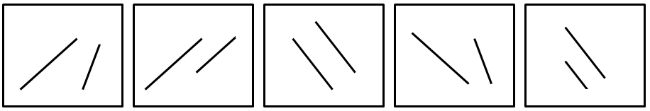

- Circle the sets of lines below that are NOT parallel:

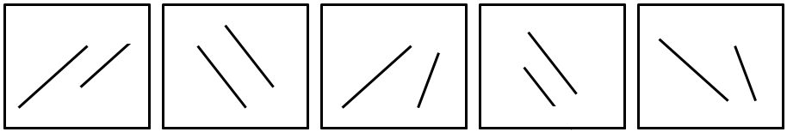

- Using the method shown in the examples below, extend the lines and draw circles around any intersections for the two sets of lines on the right.
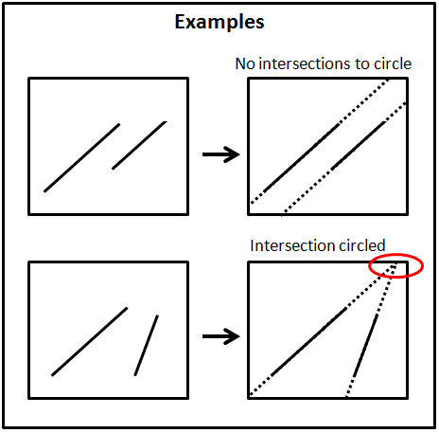
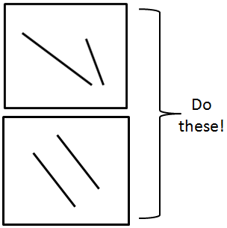

- If two trains were running parallel to each other, would they be in danger of crashing into each other? Why or why not?

- What type of engineer designs railways?

