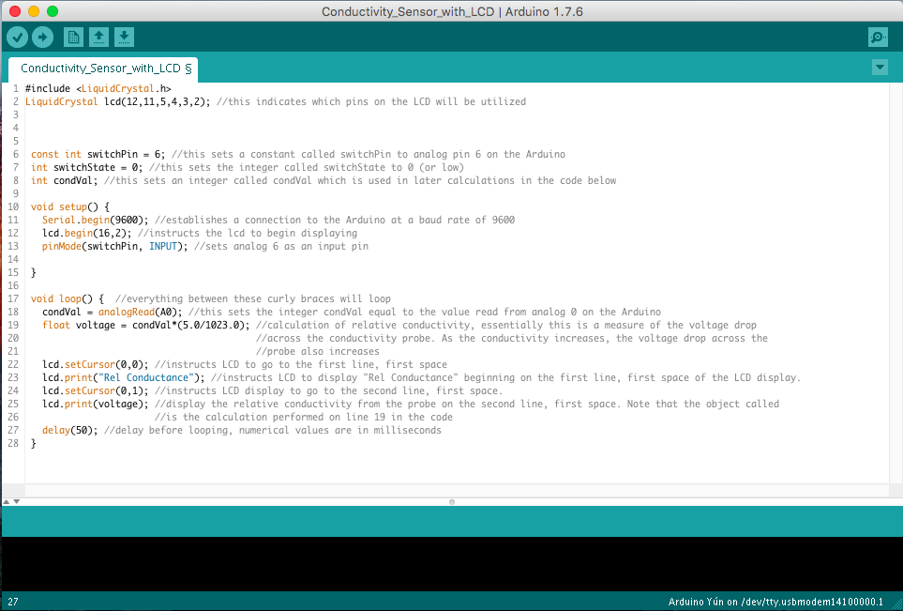
Arduino Code Comments for the Teacher

