Powerful Pulleys: The Power of Mechanical Advantage Activity – Pulley Setup Assembly Instructions

Today you are going to build your very own LEGO® pulley setup. The following step-by-step instructions will guide you through the process.
Assembly of LEGO® Modules
- Follow the two separate building instructions using two LEGO® Education Kits. The instructions are in .html format, so you will need a web browser to view the files.
- Once assembled, put the modules to the side for the time being.
Construction of Mounting Pieces
- Gather materials for the constructions process:
  - one 12” x 20” x ¼” thick piece of modeling wood (e.g., basswood) or Plexiglas® (at least large enough to accommodate the mounting template; see Mounting Template.pdf attachment)
  - one 9” x 9” x ¼” think piece of wood/Plexiglas® (for the platform to hold the load)
  - Power drill
  - 3/16” diameter drill bit (appropriate for wood and/or Plexiglas®)
- Print out the Mounting Template document.
- Tape down the mounting template onto the 12” x 20” piece of wood/Plexiglas®, centering as best as possible. Orientation is a matter of preference to the user.
- Drill 3/16” holes into the indicated positions on the template.
- Remove template after all holes are drilled.
- For the load platform, drill 3/16” holes near the corners of the 9”x9” wood/Plexiglas® platform.
Programming of LEGO® Module
- Open the LEGO® MINDSTORMS® EV3 pulley_station.ev3 and pulley_remote.ev3 files using EV3-G programming software, which accompanies the LEGO® Education Kits.
- Connect the EV3 bricks to the computer using a USB cable, and download each program to the two bricks.
- Ensure that the bricks are able to successfully run the programs without error. Motors and button sensors should not be connected to the bricks at this point.
Insertion of Line into LEGO® Module
- Tie the string/fishing line to the spool of the LEGO® pulley module, which is attached to the motors. Allow enough slack to accommodate the expected height off of the ground. This will take assistance from the instructor.
- For the load platform, tie string/fishing line of equal lengths to each of the corners, attaching through the four holes that were previously drilled.
- Tie the opposite end of each string piece to an end of a 2x9M LEGO® Technic beam (see figure).
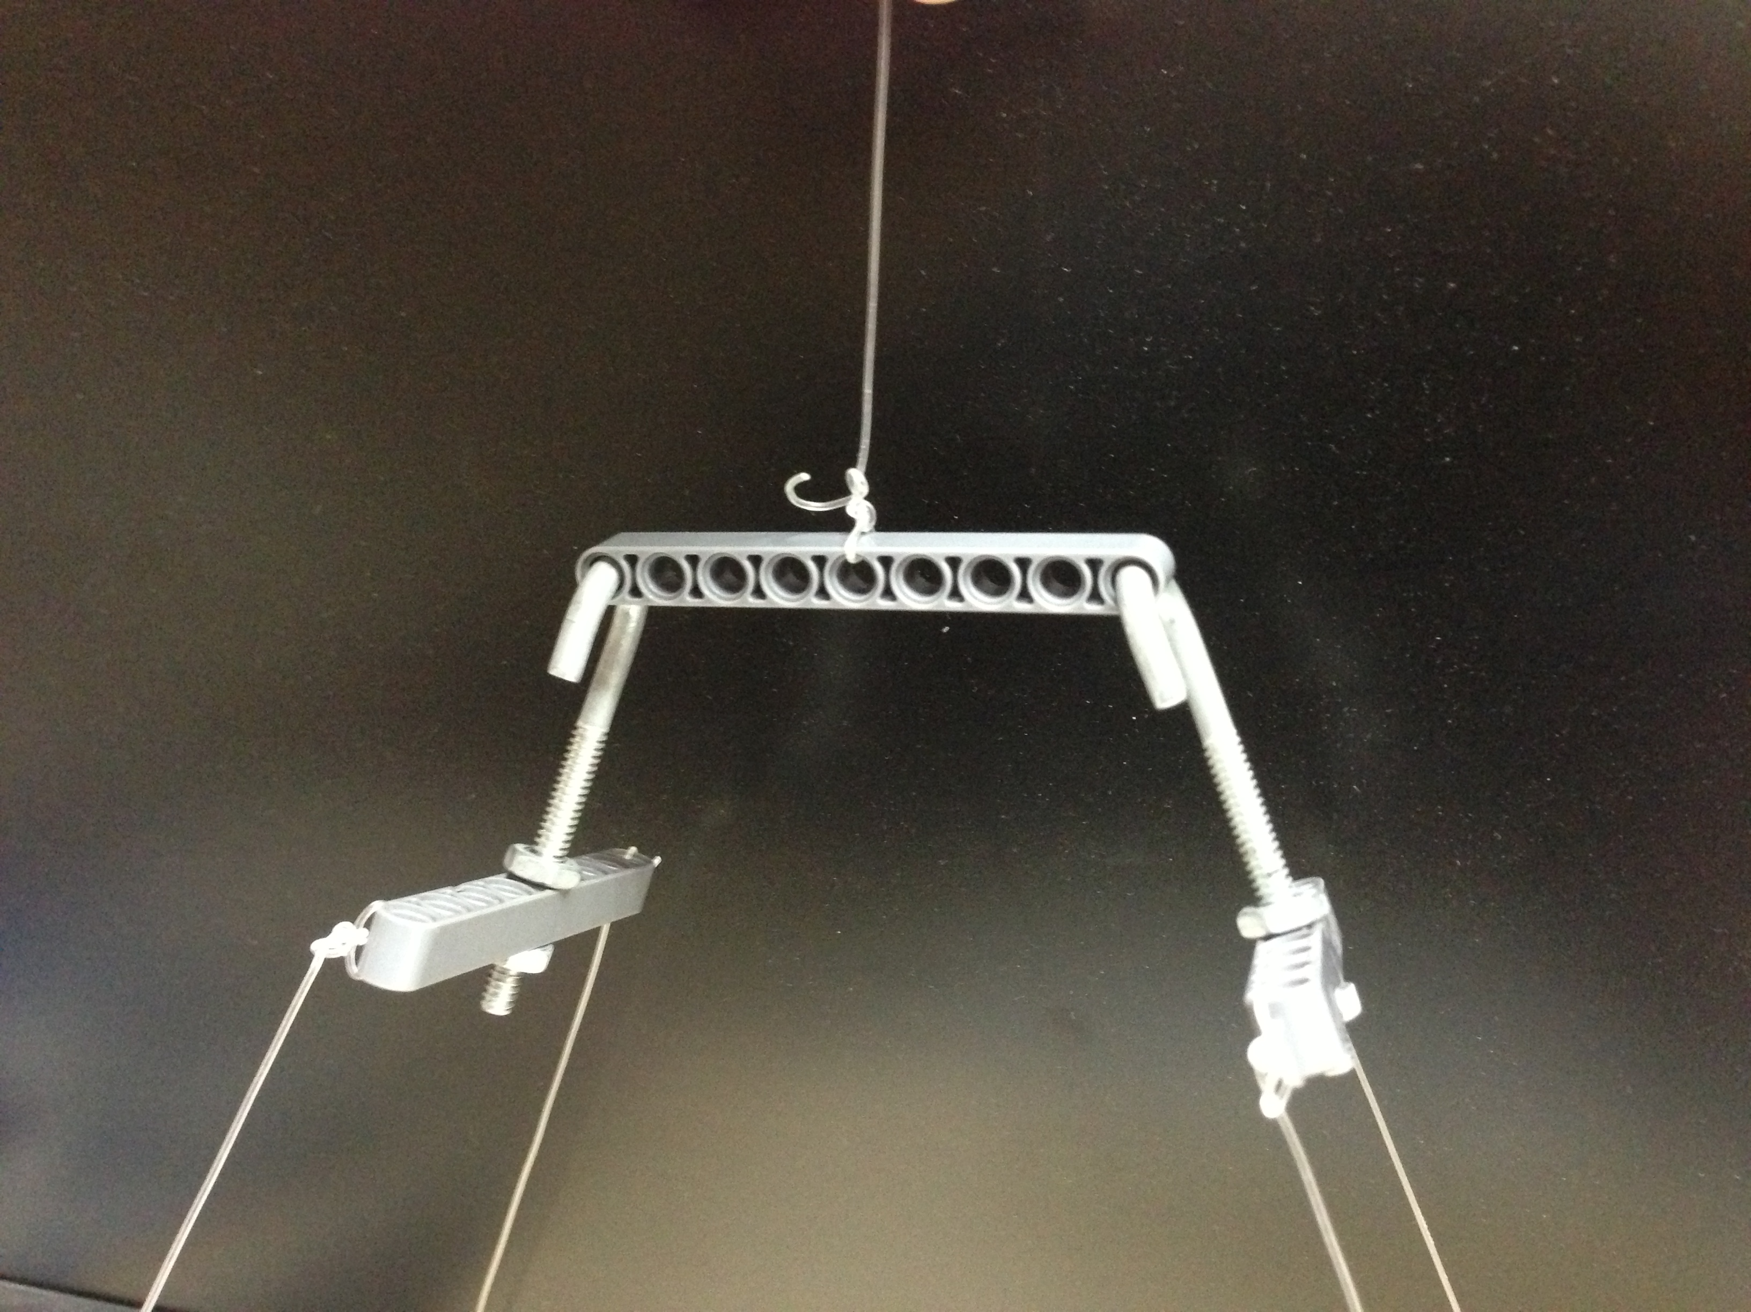
- Thread one nut halfway up the threaded length of each of the two screw hooks.
- Pass the hooks (with the nut attached) through the middle hole of the 9M beams, and lock them into place using an additional nut for each hook (see figure).
Mounting of LEGO® Module
- Line up the LEGO® pulley modules with the holes that were drilled into the mounting plate.
- Pass zip ties through the holes, ensuring the setup is flush with the mounting plate.
- Thread the string/fishing line though the immobilized pulleys, and tie the end of the line to middle of a 9M beam after it passes through the non-moving pulley. This will prevent the line from getting eaten up by the spool and also allows for easy addition of the two moving pulleys. The screw hooks can be passed through the ends of this 9M beam to attach the platform to the system.

Congratulations! You now have a LEGO® pulley system.
How much weight can you lift?

