Putting Robots to Work with Force & Friction Activity –
Force & Friction Quiz

- What does the word “force” mean?
  - A push
  - A push or pull
  - A pull
- Use the image below to complete the next question. Using the ruler displayed, what is the length of the car shown to the nearest centimeter?

  - 6 centimeters b. 7 centimeters c. 9 centimeters
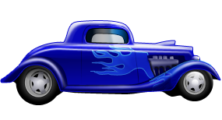
- Which of the following objects requires more force to move?
  - A marble
  - An elephant
  - A basketball
- What does friction do to a moving object?
  - Slows the object down
  - Speeds the object up
  - No effect
- How do engineers use models and experiments to produce better machines?

