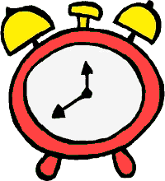
Robo Clock Activity Data Worksheet

Use the Robo Clock to answer the following questions:

1. Allow the robot to make 1 rotation in the clockwise direction
from 12:00 PM spot. How many degrees did the robot turn? ________

2. Based on what the clock shows, how many minutes have passed since 12:00 PM? _________
3. What is the time now on the clock? ________
4. Allow the robot to make 2 rotations in the counter clockwise direction from 12:00 PM spot. How many degrees did the robot turn? ________

5. How many minutes have passed since 12:00 PM? _________
6. What is the time on the clock? ________
7. Allow the robot to make 4 rotations in the clockwise direction from 12:00 PM spot. Did the robot come back to its original spot? _________

8. How many degrees did it turn? ____________________

