Mapping Perimeter!

In this activity you will see how a robot can help you learn about an environment!

Find the measurements of each side using the robot and draw your map to scale on this grid. Label each of the sides with the measurements found by the robot.

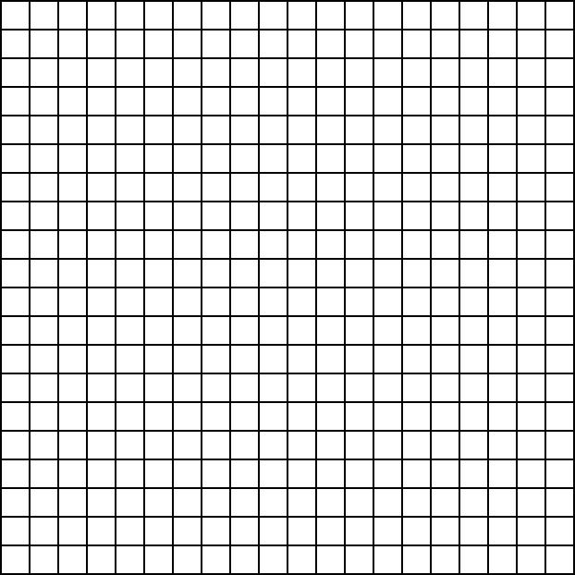

What is the perimeter of your shape? __________________
Show your work here:

Measure the shape with a ruler, and draw the shape to scale on the grid below. This time, label each side with the measurements you found with your ruler.

What is the perimeter using your measurements? _______________
Show your work below.

Were the measurements the same? ___________.

Why do you think that is?

___________________________________________________________________________________

___________________________________________________________________________________

___________________________________________________________________________________

___________________________________________________________________________________

___________________________________________.

Why might it be useful sometimes to use a robot instead of measuring yourself?

___________________________________________________________________________________

___________________________________________________________________________________

___________________________________________________________________________________

___________________________________________________________________________________

___________________________________________.

