Sensing Your Surroundings Building Instructions

Materials
LEGO NXT brick
7 port-sensor/motor wires
3 black medium axles
3 black small axles
2 gray mini axles
2 7 x 1 x 3 angle
8 yellow thin washers
2 gray washers
20 black connectors
2 black long connectors
2 5 x 3 L-shape
1 1 x 3 long
1 1 x 5 long
1 1 x 9 long
9 blue connectors
2 black axle connectors
4 gray axle-LEGO connectors
1 2 x 2 gray connector
2 large gears
1 small gear
2 medium wheels
2 motors
2 touch sensors
1 light sensor
1 sound sensor
1 ultrasonic sensor

Step 1
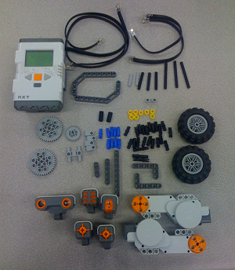
Acquire all of the pieces shown above.

Step 2
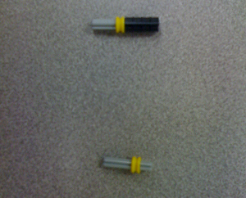
Obtain: 2 gray mini axles, 2 yellow thin washers, 1 black axle connector. Connect as shown above; then connect to the back of the motor, as shown in Step 3.

Step 3
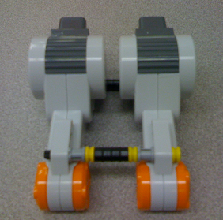
Obtain: 2 motors, 3 small black axles, 3 yellow thin washers, 1 black axle connector, 2 gray washers. Connect as shown above.

Step 4
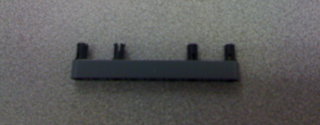
Obtain: 4 black connectors, 1 1x9 long. Connect as shown above.

Step 5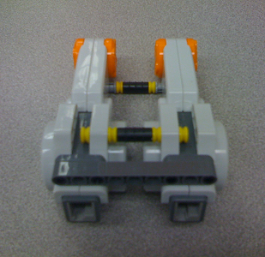
Connect piece from Step 4 to back of motors, as shown above.

Step 6
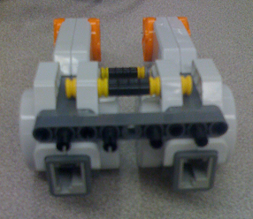
Obtain: 4 black connectors. Connect as shown above.

Step 7
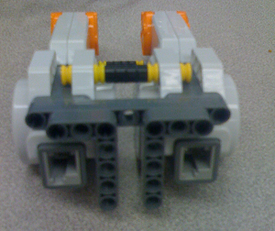
Obtain: 2 5x3 L-shapes. Connect as shown above.

Step 8
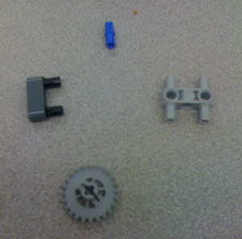
Obtain: 1 small gear, 1 1x3 long, 1 blue connector, 1 2x2 gray connector, 2 black connectors. Connect as shown above.

Step 9
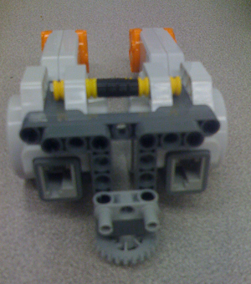
Connect the pieces obtained from Step 8 as shown above. First, connect the 2 black connectors to the 2x2 gray connector; connect to the L shape; then, use blue connector to connect small gear.

Step 10
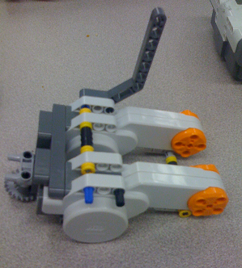
Obtain: 2 black connectors, 2 blue connectors, 2 7x1x3 angles. Connect the blue and black pieces to each side of the motors as shown above, repeat for second side.

Step 11
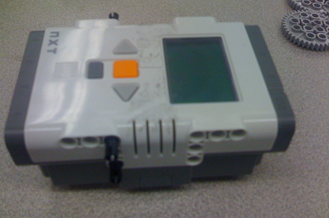
Obtain: 4 black connectors, LEGO NXT brick. Connect as shown

Step 12
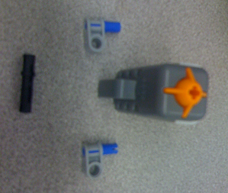
Obtain: 2 touch sensors, 4 blue connectors, 2 black long connectors, 4 gray axle-LEGO connectors. Connect as shown.

Step 13
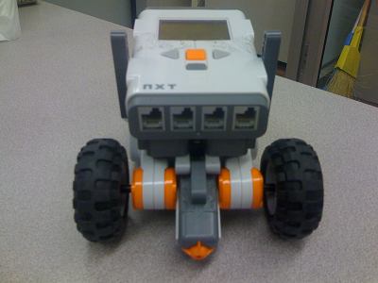
Connect: 2 gray axle-LEGO connectors to NXT brick using blue connectors; then connect touch sensor using black long connector as shown; set second touch sensor.
Step 14
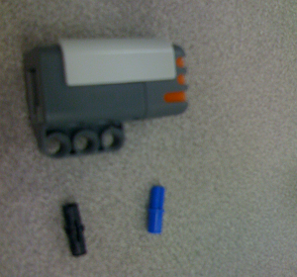
Connect the sound sensor and light sensor in the same manner. Obtain: 1 sound sensor, 1 blue connector and 1 black connector as well as 1 light sensor, 1 blue connector and 1 black connector.

Step 15
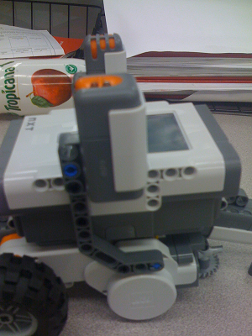
Connect sound sensor with blue and black connectors to angle, as shown. Do the same for the light sensor on the other side.

Step 16
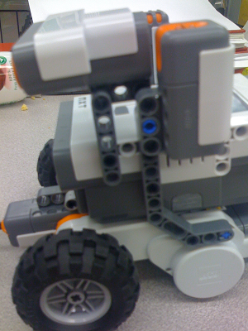
Obtain: 1 ultrasonic sensor, 1 1x5 long, 1 black long connector, 2 black connectors, and 1 black connector. Connect black long connector to light sensor. Connect ultrasonic as shown above.

Step 17
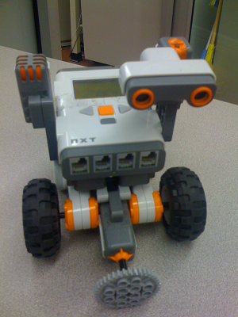
Obtain: touch sensor pieces from Step 13, 2 medium wheels, 1 large gear, and 3 black medium axles. Connect touch sensor as shown in Step 13; connect medium wheels with medium axle and gear with medium axle, as shown above.
Step 18
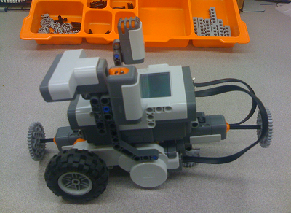
Obtain: 1 large gear, 1 black medium axle. Connect as shown.

Step 19
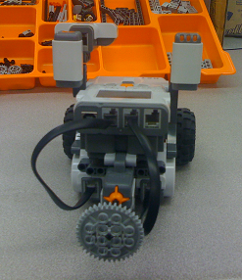
Obtain: port-sensor/motor wires and connect each motor/sensor to appropriate ports.

