Triangles Activity Assessment Answers
- Briefly explain each type of triangle:
- scalene: A triangle whose sides are all unequal in length.
- isosceles: A triangle with two sides equal in length.
- equilateral: A triangle with all three sides equal in length. Also, all three angles are equal.
- What is special about a right triangle? __A right triangle has one right (90°) angle. _
Use the image below to complete the next questions.
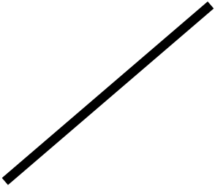
- Draw a diagonal line across the square to connect the dots shown.

- Circle the kind of triangle that is now shown above.
- isosceles triangle
- equilateral triangle
- equiangular triangle
- If the length of the bottom line of the triangle is 2 inches, then what is the length of the opposite side? ___2 inches___
- If the length of the bottom line of the triangle is 2 inches, then will the length of the hypotenuse be greater or smaller than 2 inches? __ greater than 2 inches__
(Note: to answer question 6, students do not need to use the Pythagorean Theorem since the hypotenuse will always be the longest side in a triangle.)
- If every angle between the sides of a square is 90 degrees, then what is the angle formed by drawing a line half-way through the 90-degree angle? ___ 45 degrees______

