Activity Worksheet
Challenge Question: How can we estimate the height of an object?

Observations
Application: The height of the ceiling
Initial height guess | 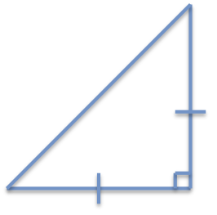

Distance to wall

Predicted height

Measured height

Explanation and notes:

Synthesis: On top of an object

Initial distance guess

Height of observer on object

Predicted distance to object

Measured distance to object

Explanation and notes:

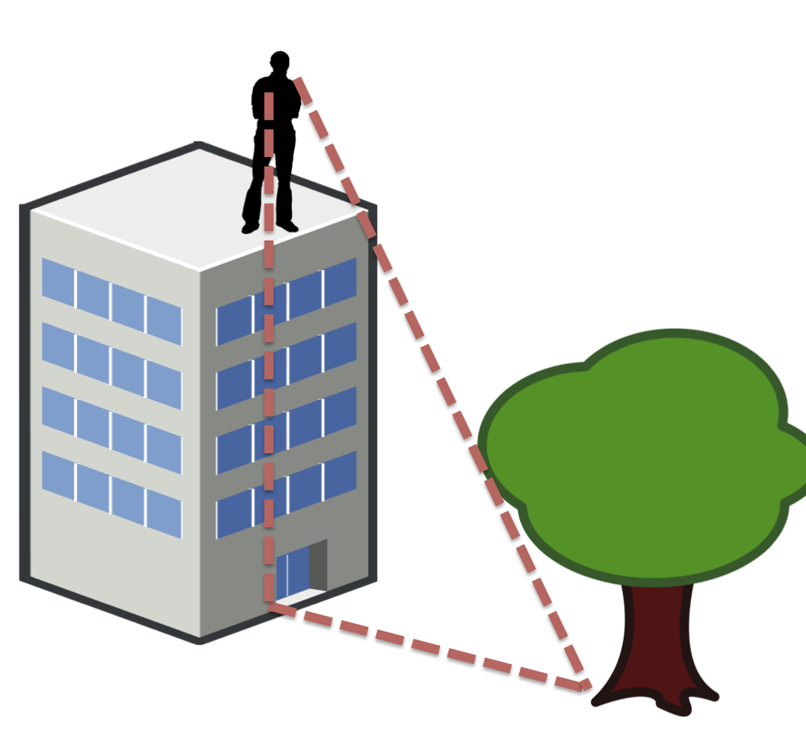
Reflection: Based on the information you have learned in this activity, how can you use triangles to estimate the height of objects?

