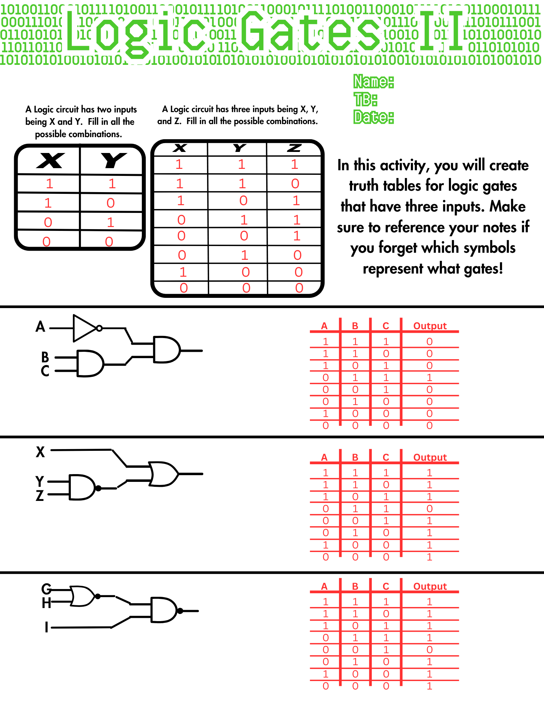**Logic Gates II Worksheet Answer Key**