Nitrogen Cycle Worksheet Answer Key

Group roles: There are three people in your expert group. Each member should choose one of these roles to make sure your group is working productively:
- Timer - keeps track of time and keeps the group work moving forward
- Reader - reads the instructions and rubrics for the group
- Ambassador - asks questions that the group is unsure of.

Instructions: As a team, read the information provided at this link (https://openoregon.pressbooks.pub/envirobiology/chapter/3-2-biogeochemical-cycles/) to learn about the nitrogen biogeochemical cycle and then individually answer the questions below. Once each team member has answered these questions, discuss your answers as a group. If needed, additional research links are provided at the bottom of this document.

- What is a biogeochemical cycle?
Biogeochemical cycles are the pathways a substance takes in the ecosystem as it moves between being in the environment, then being in a living thing, and then back to being in the environment.

- When does nitrogen move from a biotic factor to an abiotic factor?
Nitrogen moves from biotic to abiotic when organisms decompose and denitrifying bacteria release nitrogen gas.

- When does nitrogen move from an abiotic factor to a biotic factor?
Nitrogen goes from abiotic to biotic when it is taken in by nitrogen fixing bacteria.

- As a group, draw a picture of the nitrogen cycle. Each group member should contribute to the poster, for example: one member draws the images, one member writes the labels, one member draws the arrows. Arrows showing the movement of nitrogen in your poster should be drawn in red. The poster should include:
- Label the following terms on your poster: nitrogen fixation, ammonification, nitrification, assimilation, denitrification
- The following images need to be shown on your poster: decomposers, plants, animals, nitrogen fixing bacteria (on legume roots and in soil), nitrifying bacteria, denitrifying bacteria (please add more images as you see fit)
- Identify nitrogen moving from a biotic factor to an abiotic factor
- Identify nitrogen moving from an abiotic factor to a biotic factor
- Include pictures and labels for at least three ways humans impact this cycle
- Red arrows showing the flow of nitrogen in the cycle

Answers vary. Example below.

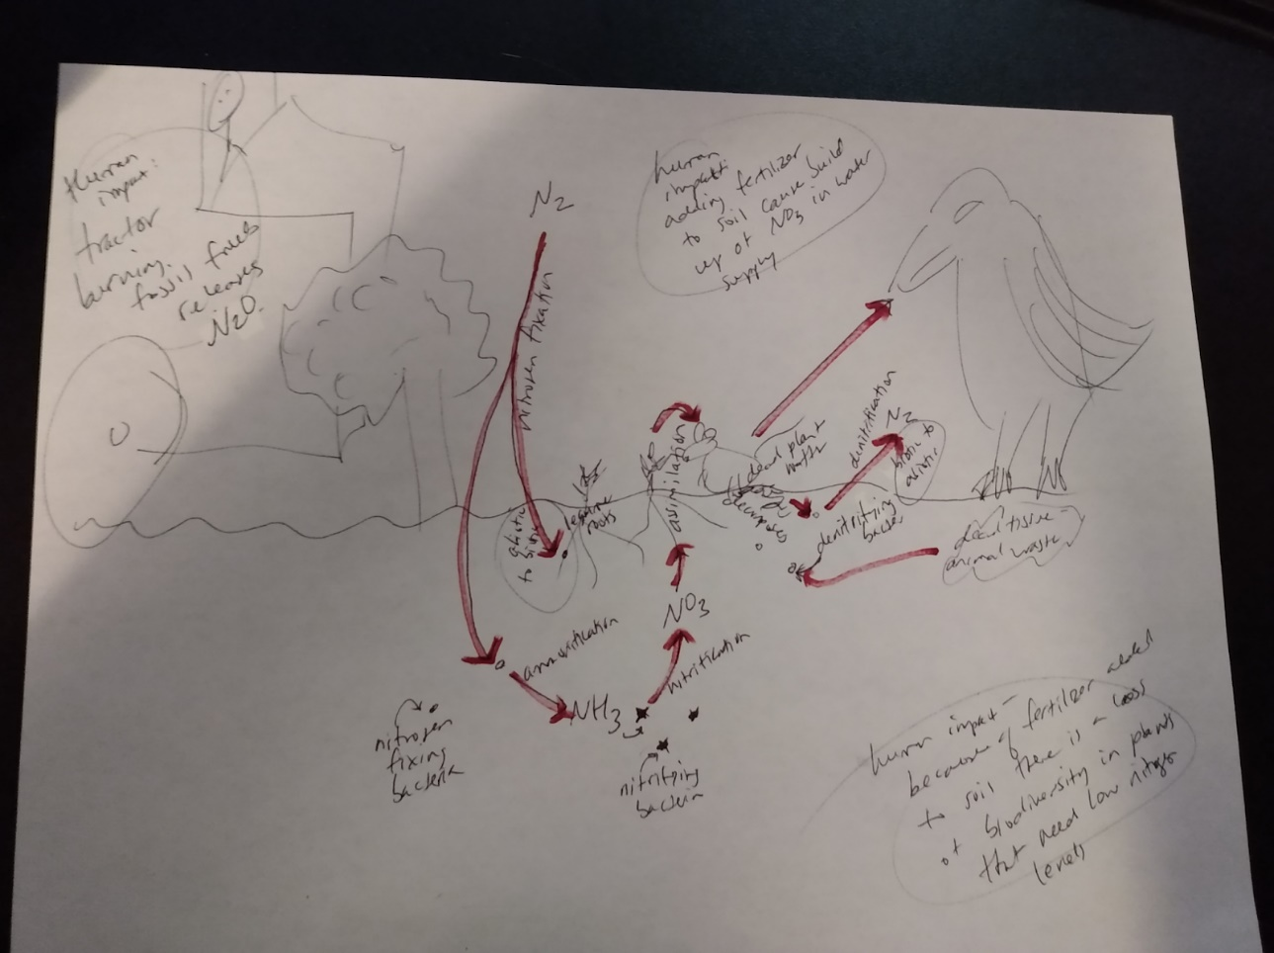

5. Answer these questions individually and then discuss your ideas with your group.
  - Describe how a building/structure could fit into the nitrogen cycle - you have creative license; this can be realistic or hypothetical. You should have at least 3 examples in the description.
Answers vary, this depends on the type of building the student groups design

  - Write an example and explanation for at least 3 ways humans can reduce their impact on the nitrogen cycle. How does your building design decrease human impact on the nitrogen cycle?

  - If possible, identify any Intersections between the nitrogen cycle and other cycles.

Links for extra nitrogen cycle research:
https://scied.ucar.edu/learning-zone/earth-system/biogeochemical-cycles
https://nca2014.globalchange.gov/report/sectors/biogeochemical-cycles
https://courses.lumenlearning.com/biology2xmaster/chapter/biogeochemical-cycles/

