Water Cycle Worksheet Answer Key

Group roles: There are three people in your expert group. Each member should choose one of these roles to make sure your group is working productively:
- Timer - keeps track of time and keeps the group work moving forward
- Reader - reads the instructions and rubrics for the group
- Ambassador - asks questions that the group is unsure of.

Watch this video (https://www.youtube.com/watch?v=bdnUWRmCMD8) together as a team to introduce human impact on the water cycle, then read the information provided on this link (https://www.noaa.gov/education/resource-collections/freshwater/water-cycle) to learn about the water biogeochemical cycle and answer the questions below. If needed, additional research links are provided at the bottom of this document.

Answer these questions individually and then discuss them with your group.
- What is a biogeochemical cycle?
Biogeochemical cycles are the pathways a substance takes in the ecosystem as it moves between being in the environment, then being in a living thing, and then back to being in the environment.
- When does water move from a biotic factor to an abiotic factor?
Water moves from a biotic factor into an abiotic factor when it leaves a plant during transpiration or when it leaves an animal in their sweat, urine, or water vapor from exhaling.
- When does water move from an abiotic factor to a biotic factor?
Water moves from an abiotic factor into a biotic factor when it gets taken up by the roots of a plant or is consumed by an animal.

- As a group, draw a picture of the water cycle. Each group member should contribute to the poster, for example: one member draws the images, one member writes the labels, one member draws the arrows. Arrows showing the movement of water in your poster should be drawn in blue. The poster should include:
- Label the following terms on your poster: evaporation, condensation, precipitation, surface runoff, transpiration, ground water, root uptake
- The following images should be shown on your poster: plants, animals, ocean/lake (please add more images as you see fit)
- Identify water moving from a biotic factor to an abiotic factor
- Identify water moving from an abiotic factor to a biotic factor
- Include pictures and labels for at least three ways humans impact this cycle
- Blue arrows showing the flow of water through the cycle

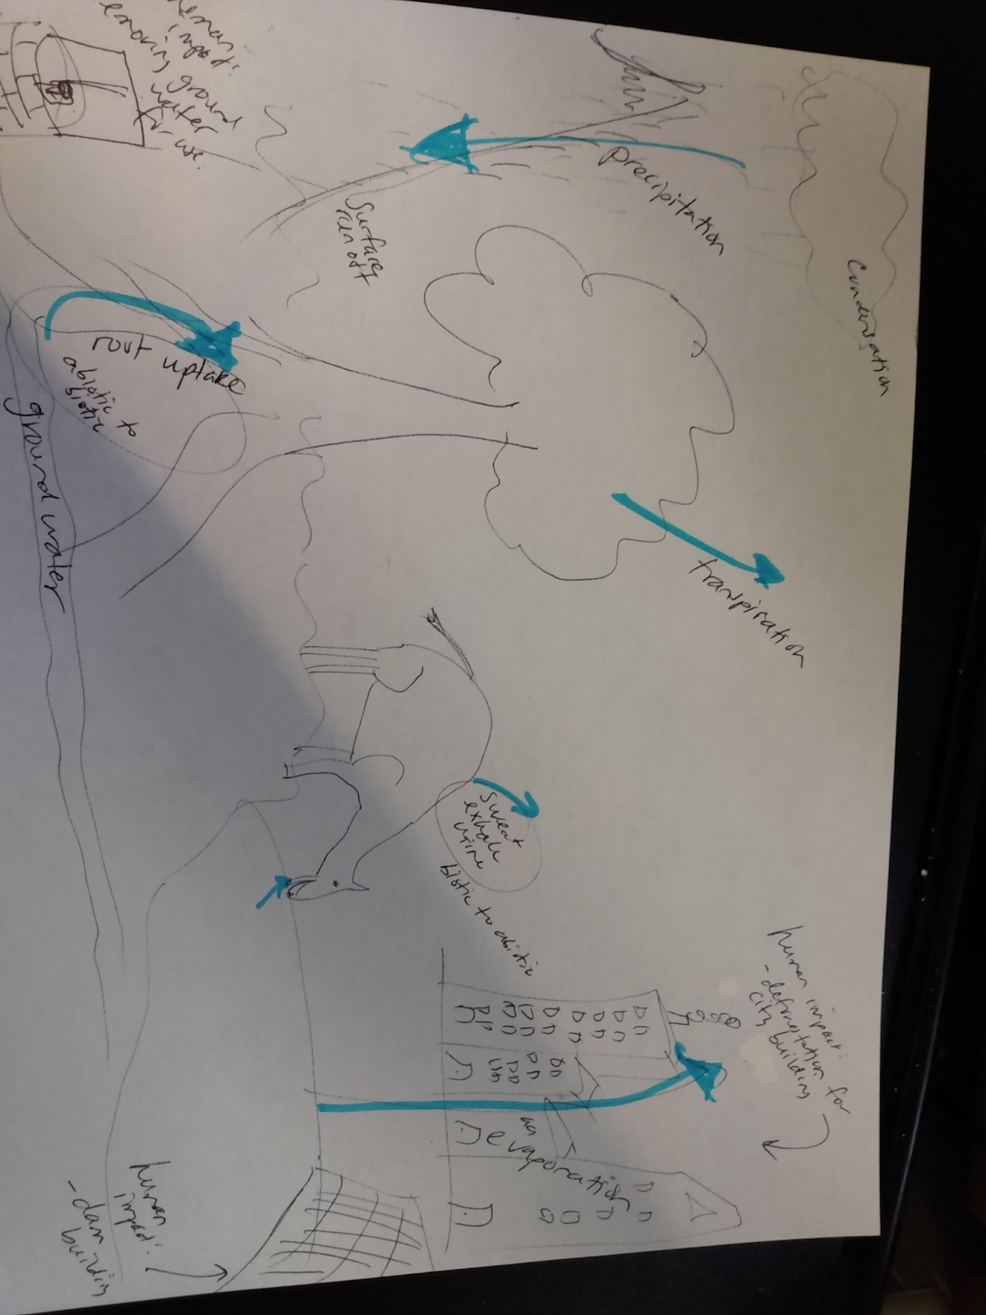

- Answer the following questions individually and then discuss your ideas with your group.
  - Describe how a building/structure could fit into the water cycle - you have creative license; this can be realistic or hypothetical. You should have at least 3 examples in the description.
Answers vary

  - Write an example and explanation for at least 3 ways humans can reduce their impact on the water cycle. How does your building design decrease human impact on the water cycle?
Possible answers include:
Conserve water - this will depend on the type of building students’ design
Green infrastructure to help water back into the soil instead of running off - permeable sidewalks, rain barrels, rain gardens

  - If possible, identify any Intersections between the water cycle and other cycles.
Possible connections: the burning of fossil fuel releases nitrogen oxides which cause acid rain, nitrogen, and phosphorus from fertilizer wash into rivers, go to the sea and cause dead zones.

Links for extra water cycle research:
https://courses.lumenlearning.com/biology2xmaster/chapter/biogeochemical-cycles/
https://openoregon.pressbooks.pub/envirobiology/chapter/3-2-biogeochemical-cycles/

