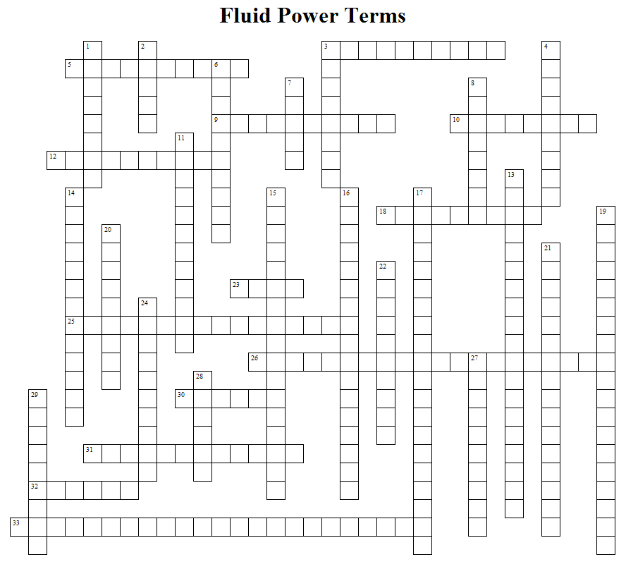
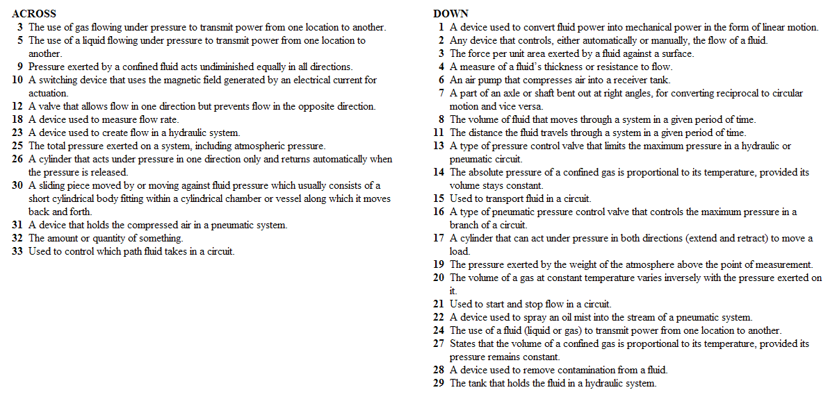

Enlarged copy of hints to Fluid Power Terms Crossword Puzzle
ACROSS
3 |  |  |  | The use of gas flowing under pressure to transmit power from one location to another.
5 |  |  |  | The use of a liquid flowing under pressure to transmit power from one location to another.
9 |  |  |  | Pressure exerted by a confined fluid acts undiminished equally in all directions.
10 |  |  |  | A switching device that uses the magnetic field generated by an electrical current for actuation.
12 |  |  |  | A valve that allows flow in one direction but prevents flow in the opposite direction.
18 |  |  |  | A device used to measure flow rate.
23 |  |  |  | A device used to create flow in a hydraulic system.
25 |  |  |  | The total pressure exerted on a system, including atmospheric pressure.
26 |  |  |  | A cylinder that acts under pressure in one direction only and returns automatically when the pressure is released.
30 |  |  |  | A sliding piece moved by or moving against fluid pressure which usually consists of a short cylindrical body fitting within a cylindrical chamber or vessel along which it moves back and forth.
31 |  |  |  | A device that holds the compressed air in a pneumatic system.
32 |  |  |  | The amount or quantity of something.
33 |  |  |  | Used to control which path fluid takes in a circuit.
DOWN
1 |  |  | A device used to convert fluid power into mechanical power in the form of linear motion.
2 |  |  | Any device that controls, either automatically or manually, the flow of a fluid.
3 |  |  | The force per unit area exerted by a fluid against a surface.
4 |  |  | A measure of a fluid’s thickness or resistance to flow.
6 |  |  | An air pump that compresses air into a receiver tank.
7 |  |  | A part of an axle or shaft bent out at right angles, for converting reciprocal to circular motion and vice versa.
8 |  |  | The volume of fluid that moves through a system in a given period of time.
11 |  |  | The distance the fluid travels through a system in a given period of time.
13 |  |  | A type of pressure control valve that limits the maximum pressure in a hydraulic or pneumatic circuit.
14 |  |  | The absolute pressure of a confined gas is proportional to its temperature, provided its volume stays constant.
15 |  |  | Used to transport fluid in a circuit.
16 |  |  | A type of pneumatic pressure control valve that controls the maximum pressure in a branch of a circuit.
17 |  |  | A cylinder that can act under pressure in both directions (extend and retract) to move a load.
19 |  |  | The pressure exerted by the weight of the atmosphere above the point of measurement.
20 |  |  | The volume of a gas at constant temperature varies inversely with the pressure exerted on it.
21 |  |  | Used to start and stop flow in a circuit.
22 |  |  | A device used to spray an oil mist into the stream of a pneumatic system.
24 |  |  | The use of a fluid (liquid or gas) to transmit power from one location to another.
27 |  |  | States that the volume of a confined gas is proportional to its temperature, provided its pressure remains constant.
28 |  |  | A device used to remove contamination from a fluid.
29 |  |  | The tank that holds the fluid in a hydraulic system.

ANSWER KEY

