Name:
Class Period:
Date:

What is Fluid Flow?

Needed Supplies: Ruler, Stopwatch, PFPD

Instructions: Read the following about fluid flow and how it relates to the PFPD you previously worked on. This particular lesson will use your knowledge of time, displacement, and velocity to determine the actual flow rate that the PFPD is delivering to each cylinder.

Theoretical Background
- Flow
  - Flow rate is defined as a volume displaced per unit time.
    - Q=VA (Equation 1.1)
    - Q is volumetric flow rate (in³ per second)
    - V is velocity (inches per second)
    - A is area (in² )
- Hydraulic Cylinders
  - In any cylinder there are two sides to the piston:
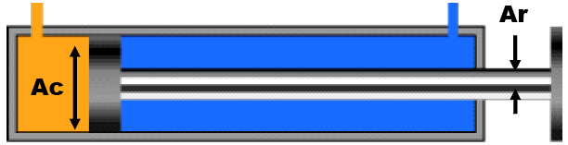

  - When the cylinder extends, the system fluid pushes against an area equal to the area of the cylinder (Ac).
    - The velocity of the cylinder rod in this case is:
    - V = Q / Ac (Equation 1.2)
  - When the cylinder retracts, the system fluid pushes against an area equal to the cylinder area minus the area of the rod. (Ac – Ar).
    - The velocity of the cylinder rod in this case is:
    - V = Q / (Ac – Ar) (Equation 1.3)
  - The difference between the areas used to extend and retract the piston is called the area ratio of the cylinder. In this case, the two areas are Ac and (Ac-Ar)
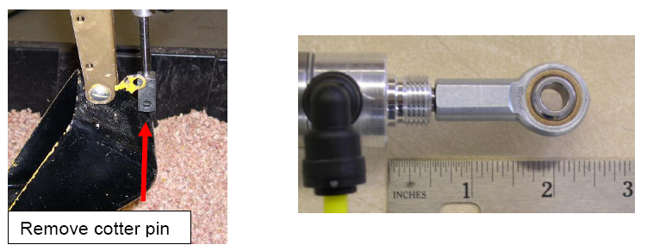
Experiment
- Turn on system pump
- Remove cotter pin and fully retract the bucket cylinder
- Place ruler at base of cylinder body (refer to picture above)
- Using ruler, measure and record the initial position of the cylinder rod (X1)
- Fully extend the cylinder and record how long it takes with stopwatch (T)
- Using ruler, measure and record the distance that the cylinder rod travelled (X2)

Data/Calculations
- Flow rate during cylinder extension
- X₁ = ______ in (initial position)
- X₂ = ______ in (final position)
- T = ______ sec (how long it took to get from X₁ to X₂)
- V = (X₂-X₁) / T = _______ in/sec (velocity)
- Ac = .44 in²
- Q = VAc = (_______ in/sec)(_______ in²)
- Q = _______ in³/sec
  - Multiply by (1 Gal/231 in³)(60 sec/1 min) to convert to GPM
- Q = _______ GPM
- Flow rate during cylinder retraction
- X₁ = ______ in (initial position)
- X₂ = ______ in (final position)
- T = ______ sec (how long it took to get from X₁ to X₂)
- V = (X₂ – X₁) / T = _______ in/sec (velocity)
- Ac = .44 in²
- Ar = .049 in²
- Q = V(Ac – Ar) = (_______ in/sec)(_______ in²)
- Q = _______ in³/sec
  - Multiply by (1 Gal / 231 in³)(60 sec / 1 min) to convert to GPM
- Q = _______ GPM

Discussion
- Convert your average flow rates into GPM. Compare your calculated average flow rates for each cylinder to the flow rate on the pump label. Why are your calculations different than what the pump is rated at? (Think about the path that the water takes through the system between the pump and cylinder.)

- Compare the ‘Extension’ and ‘Retraction’ velocities of the cylinder. Why are these velocities different? (Consider the difference between Equation 1.2 and 1.3)

