Name:
Class Period:
Date:

Moments and Mechanical Advantage

Needed Supplies: Pressure gauge, ruler

Instructions: Now that you know how cylinders produce force, we will investigate how that force is delivered through the arms of the excavator.
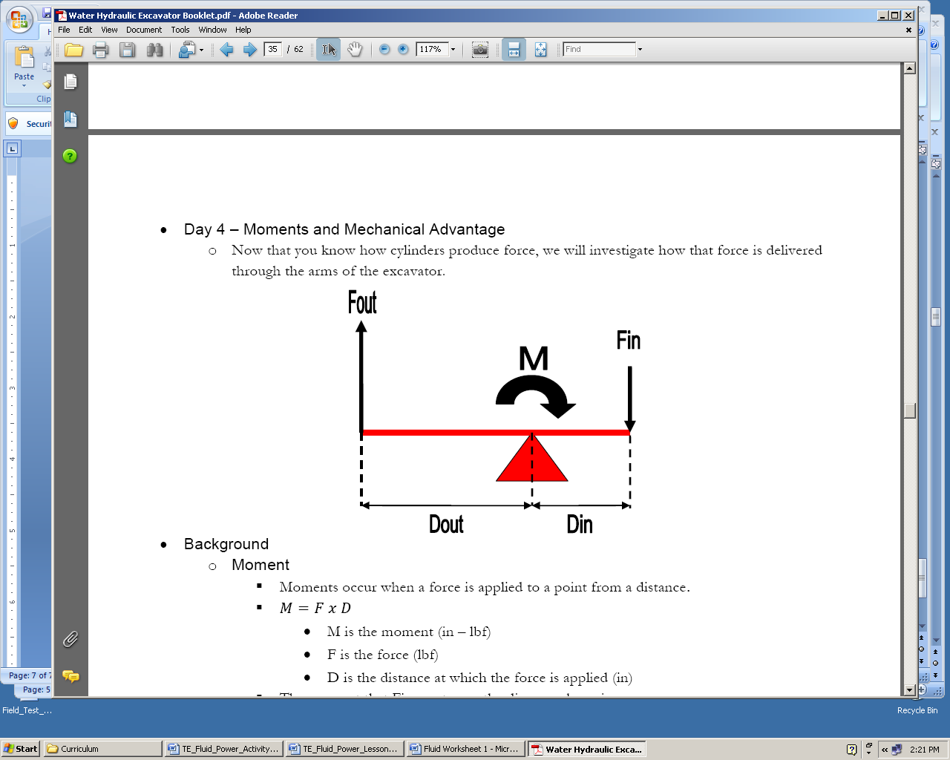
Background
- Moment
  - Moments occur when a force is applied to a point from a distance.
  - M = F x D
    - M is the moment (in – lbf)
    - F is the force (lbf)
    - D is the distance at which the force is applied (in)
  - The moment that Fin creates on the diagram above is:
    - M = (Fin) x (Din)
  - The moment that Fout creates on the diagram above is:
    - M = (Fout) x (Dout)
  - Since Fin and Fout moments act upon the same point (the red triangle), they are equal:
    - (Fin) x (Din) = (Fout) x (Dout)
  - Knowing this, if you apply a force to the lever, Fin, you will produce another force Fout, that is equal to:
    - Fout = [(Fin) x (Din)] / (Dout)
- Mechanical Advantage
  - Mechanical advantage is the ratio of the output force (Fout) to the input force (Fin).
  - MechAdv = Fout / Fin
- Moments and Mechanical Advantage on the excavator
  - The excavator uses the principles of moments and mechanical advantage to do work, with the cylinders providing the force.
  - In the picture below, the top cylinder is extending:
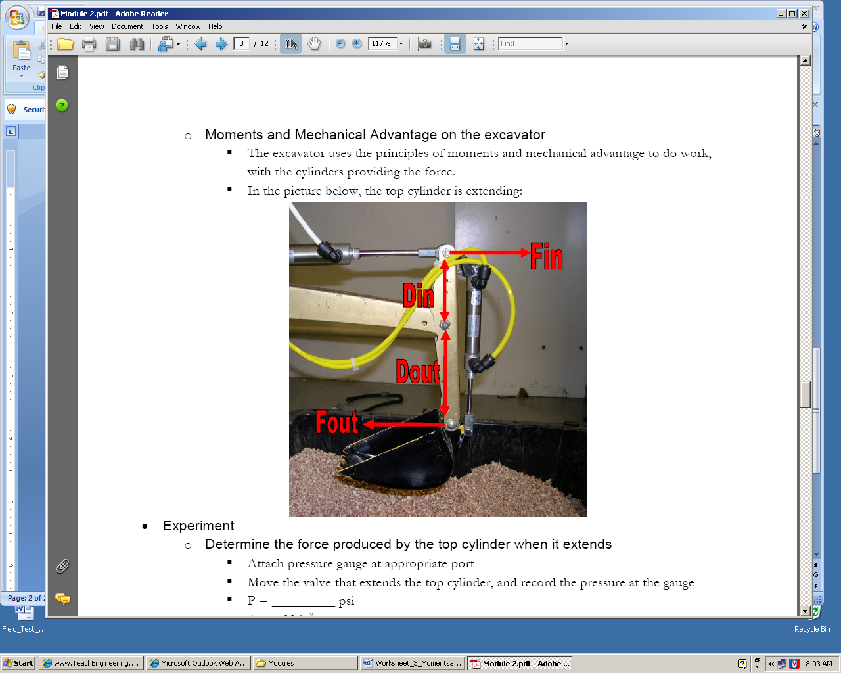
Experiment
- Determine the force produced by the top cylinder when it extends
  - Attach pressure gauge at appropriate port
  - Move the valve that extends the top cylinder, and record the pressure at the gauge
  - P = _________ psi
  - Ac = .88 in²
  - Fin = PAc = (_______psi)(_______in²)
  - Fin = _______lbf
- Measure Din and Dout on the excavator arm
  - Din = ________ in
  - Dout = _________ in
- What is Fout equal to?
  - Fout = [(Fin) x (Din)] / (Dout) = ___________
  - Fout = _________ lbf
- What is the mechanical advantage of the excavator arm?
  - MechAdv = Fout / Fin = ________
  - MechAdv = ________
Discussion
- Is the mechanical advantage different when retracting the cylinder? Explain your answer.

- What would happen to Fout and the MechAdv if Din were decreased?

- Compare the distances that each end of the excavator arm travels. Which travels further when the cylinder extends, the cylinder end, or the bucket end?

