Name:
Class Period:
Date:

Understanding Fluid Power Capabilities

Needed Supplies: Small hydraulic jack, aluminum can, jack stand to hold can in place above jack, Dial bore gauge

Instructions: Using the principles of Pascal’s Law, moments, and mechanical advantage, hydraulic jacks convert input from the jack handle into a force great enough to lift a car.

Background
- Instead of using a hydraulic motor to provide pressure, a hydraulic jack uses a small cylinder connected to a hand lever.
- Raising the hand lever
  - The outlet check valve closes and the inlet check valve opens
  - This allows fluid to flow from the reservoir, filling the pump cylinder.
- Lowering the hand lever
  - The inlet check valve closes and the outlet check valve opens.
  - This allows fluid to move from the pump cylinder to the actuator, causing it to move upward.
- Opening the needle valve
  - Relieves pressure in actuator, allowing fluid to move back to reservoir
  - This causes the actuator and the load being lifted to descend

Experiment
Determine the force required to crush aluminum can.
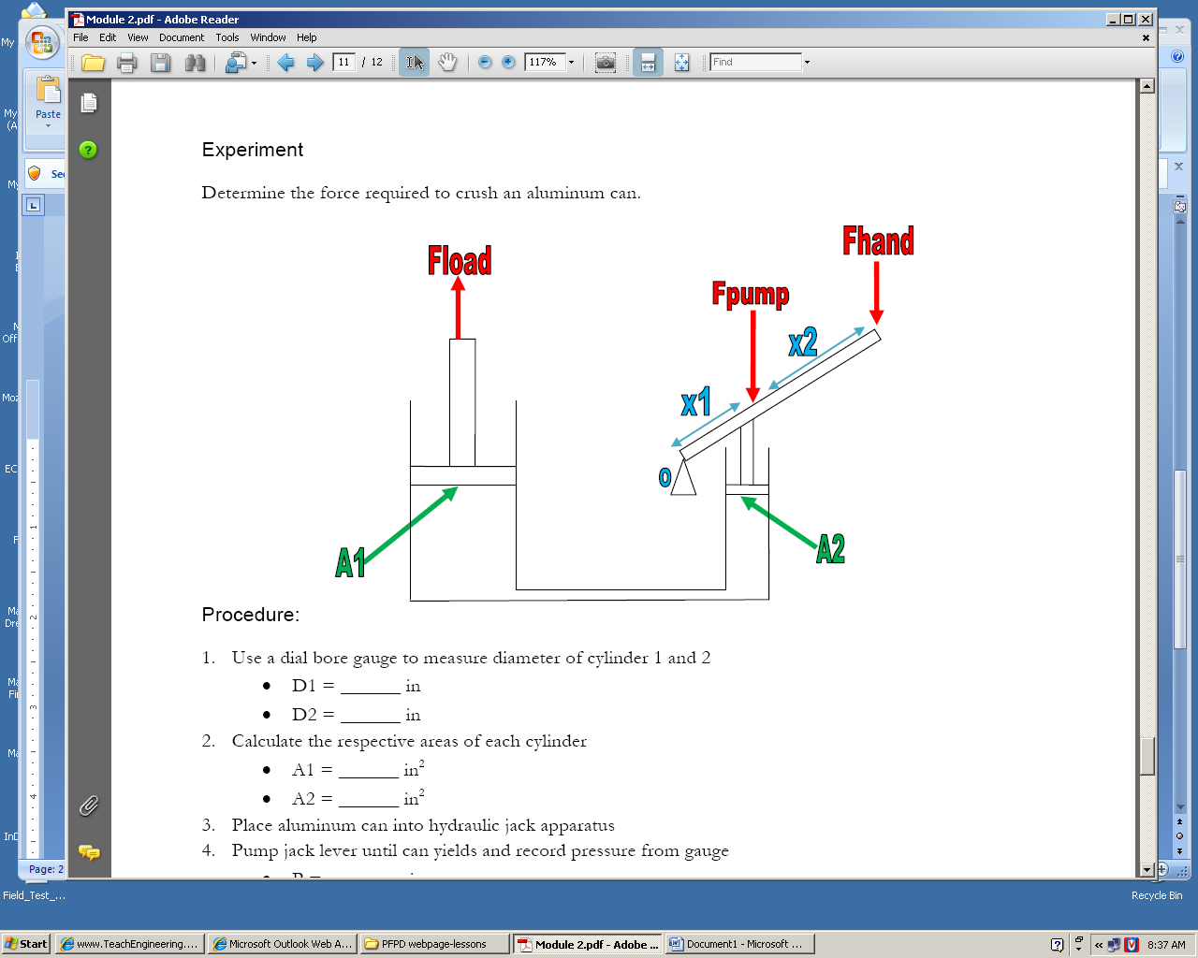

Procedure
- Use a dial bore gauge to measure diameter of cylinder 1 and 2
  - D1 = ______ in
  - D2 = ______ in

- Calculate the respective areas of each cylinder
  - A1 = ______ in²
  - A2 = ______ in²
- Place aluminum can into hydraulic jack apparatus
- Pump jack lever until can yields and record pressure from gauge
  - P = ______ psi

Calculated Fload
- Using pressure recorded and the area of cylinder 1, calculate F1
  - Fload = P / A1 = _______ lbf
Calculate Fpump
- Using pressure recorded and the area of cylinder 2, calculate F2
  - Fpump = P / A2 = __________ lbf

Calculate Fhand
- Using Fpump, x1, x2, calculate Fhand.
  - Fhand = (F2 x 1) / (X1 + X2) = ____________lbf

Calculate Mechanical Advantage
- MechAdv = Fout / Fin = Fload / Fhand = _____________

Discussion
- Without changing forces (Fhand, etc) or the sizes of the cylinders (A1, etc), how can the mechanical advantage of the hydraulic jack be increased?

- Hydraulic jacks are used to lift heavy loads and hold them in place temporarily. It is not safe to use jacks to hold loads for long periods of time. Why do you think this is? (Consider the seals/fluid in a hydraulic system)

- Hydraulic fluid is hydrophilic, meaning that it readily absorbs water from the atmosphere. With that said, why do you think it is important to change the fluid in a hydraulic jack?

