Name:
Class Period:
Date:

Bernoulli’s Equation – Energy Conservation

Needed Supplies: Empty 2-liter plastic bottle, scissors, ruler, dye, water

Theoretical Background
- Bernoulli’s Equation
  - An increase in the speed of a fluid occurs simultaneously with a decrease in pressure or a decrease in the fluid’s potential energy.
  - The left side of the equation represents point 1, with the right side representing point 2 (before and after)
    - P₁ + ¹/₂pv²₁ + pgh₁ = P₂ +¹/₂pv²₂ + pgh₂
      - This equation is based on the principle of energy conservation
        - Energy is neither created nor destroyed, but rather changes forms
      - Bernoulli’s equation contains three types of energy:
        - Pressure Energy
          - Represented by 𝑷_{𝟏} and 𝑷_{𝟐}
        - Kinetic Energy
          - Represented by ¹/₂ 𝝆𝒗^{𝟐}_{𝟏} and ¹/₂𝝆𝒗^{𝟐}_{𝟐}
          - 𝝆 is the density of the fluid
          - 𝒗 is the velocity of the fluid
        - Potential Energy
          - Represented by 𝝆𝒈𝒉_{𝟏} and 𝝆𝒈𝒉_{𝟐}
          - 𝝆 is the density of the fluid
          - g is the acceleration due to gravity
          - h is the height of the fluid from the designated zero point

Experiment
- A 2 Liter soda bottle with a hole will be used for this experiment

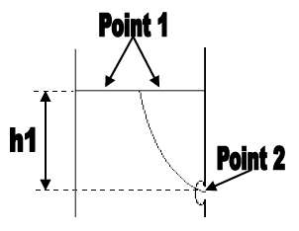
- Point 1 – The surface of the water in the bottle
    - 𝑷𝟏 is zero because of atmospheric pressure
    - 𝒗𝟏 is assumed to be zero for this experiment
    - 𝒉𝟏 will be recorded as water level decreases
  - Point 2 – The hole at the bottom of the bottle
    - 𝑷𝟐 is zero because of atmospheric pressure
    - 𝒗𝟐 is unknown but will be calculated
    - 𝒉𝟐 is zero because ℎ1 is measured from point 2
  - Solving the equation for v2
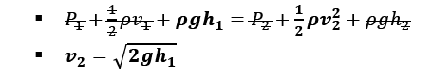

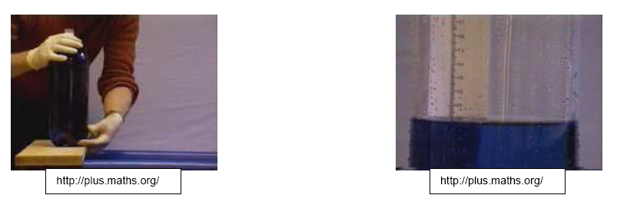

Procedure
- Obtain a 2 liter soda bottle and create a small hole on the bottom side
- Cut off the top of the bottle and insert a ruler
- Fill with water/dye, keeping the hole plugged
- Let water flow out
- Measure the height of the fluid (ℎ1) at 10 different points as the water flows out
- Record results in Data/Calculations section
- Calculate 𝒗𝟐 for each point

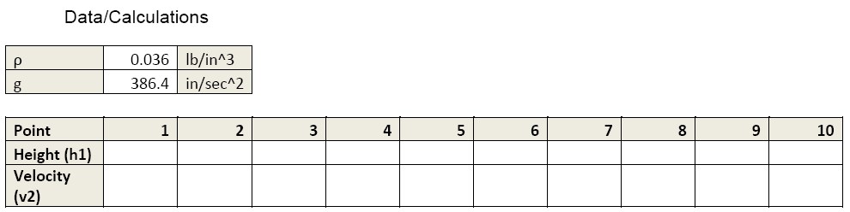

Discussion
- Describe what happens to the velocity of water flowing out of the bottle as the water level (h1) gets lower.

- What assumption becomes invalid when the hole size is large enough to make the water at point 1 move with a significant velocity?

- What would happen to 𝒗𝟐 if the top of the bottle is sealed and hooked up to an air compressor?

