Name:
Class Period:
Date:

Energy Storage

Needed Supplies: Air compressor, valve, cylinder, piping/tubing, weight, pressure gauge, ruler, stopwatch

Background
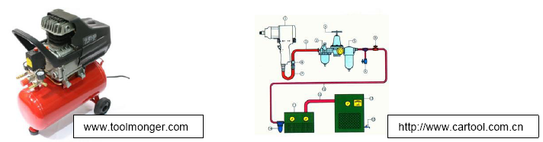

  - Air compressors are used every day to do jobs that would otherwise be difficult to do with ordinary hand tools.
  - Air compressors use an air pump to convert mechanical energy to fluid energy, store that energy in a tank, and then expel it through a cylinder or motor, converting it back to mechanical energy.
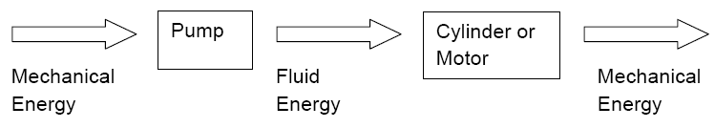
- Asdf
  - Work
    - Work is defined as force times distance
    - W = FD
      - F in lbs
      - D in inches
  - Power
    - Power is defined as work per unit time
      - Power = Work / t
    - Hydraulic power is the product of Pressure and Flow Rate
      - Power = PQ
        - P in psi
        - Q in in³/sec
  - Efficiency
    - Efficiency is the ratio of power input to power output
      - e = Output power / Input power
Experiment
- In this experiment you will follow the path of compressed air from a tank to a cylinder attached to a weight
- The air within the air compressor tank is stored energy, and creates power when released at a certain pressure (P) and a flow rate (Q).
  - Refer to the specifications of the air compressor model that you are using, specifically what flow rate (in CFM, cubic feet per minute) it can deliver at a certain pressure.
- When the air reaches the cylinder, work is done by the cylinder (a force is applied over a distance)
  - Power is produced during the extension of the cylinder as well (Work/time)
- Between the air tank and the cylinder, power is lost through friction in the pipes as well any leaks in the system
  - It is possible to determine how efficient the system is by dividing the output power at the cylinder by the input power from the compressor tank
Procedure
- Plumb a basic air circuit with 1 valve and 1 cylinder and connect to an air compressor
- Make sure that air compressor has a pressure gauge.
- Attach an object of known weight to the extended cylinder
- Retract the cylinder and record the following:
  - How long it takes to lift the weight
  - The pressure reading from the gauge
  - The distance that the weight travels
Data Calculations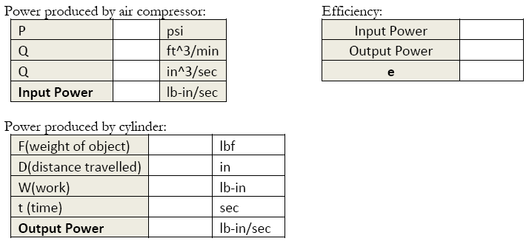
Discussion
- What generally increases with the size of an air compressor tank? (Consult your instructor or online resources if necessary)

- Would decreasing the length of tubing between the tank and cylinder increase or decrease the efficiency of the system? Explain your answer.

- What does an efficiency of 1 mean? Why is the generally not possible in the real world?

