Nanotechnology Scavenger Hunt Student Sheet Answer Key

Teacher Instructions:
- When creating the wall documents, be sure to not include the Answer of the question on the same page as its QR code, always use the one below it.
- For example, on the first wall display: Answer 14 would be placed at the bottom of the page, the Heart Symbol would be placed at the top of the page, but QR code # 2 would be place in the middle of the page.
- Follow this same pattern for the rest of the pages. Creating the pages in this manner will create a cycle for the students to go through.
Answer | Questions | QR Code | Symbol
14 | As of 2017, __________ different types of breast cancers have been identified with the aid of nanotechnology.
69% | If cars were made out of advanced composite materials, __________ percentage of gas could be saved.
2015 | In 2009, The National Science Foundation projected nanotechnology as a $1 trillion market by __________.
65% | Nanotechnology could boost the efficiency of 2017 solar cells of 20-30% to __________. |  | 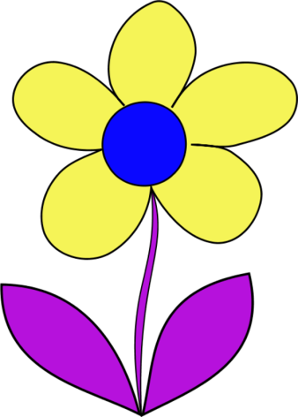
10⁻⁹ | Nano is the prefix used to show __________. |  | 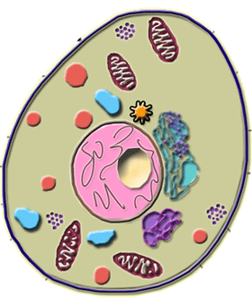
10,000 nm | The smallest things that the human eye can make out are around __________ in size. |  | 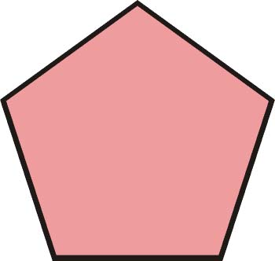
100 nm | To be considered nano, a material must have at least one dimension less than __________.
1180 ft | As of 2005, the Guinness Record for the world’s largest nanotube model is __________. |  | 