Lab Activity Handout

Problem: Which nanoparticle will bleach (or “photo-sanitize”) water the fastest after UV light exposure: titanium dioxide, zinc oxide, or magnesium oxide?
Hypothesis: I predict that________________________________________________________________
because _____________________________________________________________________________.
Materials:
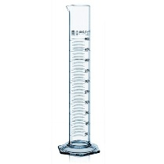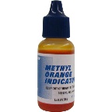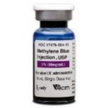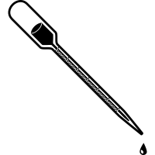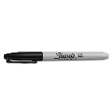
SAFETY
Equipment

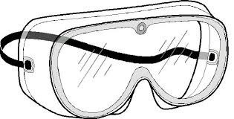
___________
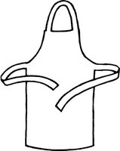
____________

___________ _______________ ______________ ___________ ________
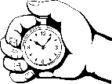 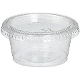 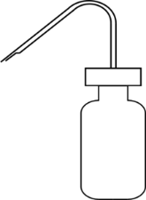 ZnO_______________________
___________ ___________ _________________ MgO _____________________
TiO₂______________________
Procedure:
- Collect all _______________; designate responsibilities to each lab group member, if needed.
- Obtain ______ plastic cups with lids and pour ________ ml of distilled water into each cup.
- Pour _______ml of methyl ___________ into the 4 cups with water.
- Pour _______ml of methylene ___________ into the other 4 cups with water.
- Label the four methyl orange cups as ________________, ______________, _____________, & “CONTROL.”
- Label the four methylene blue cups as _______________, ______________, _____________, & “CONTROL.”
- Use a _____________ to place _______ drops of each sample oxide as labeled on your cups & be sure to ___________ your solution well.
- Take a _____________ of your methyl orange and methylene blue labeled cups with your phone (before light exposure) and be ready to take your cups outside for UV light exposure.
- Using a stopwatch, record the time in ____________ it takes for each sample to bleach (do not run longer than 10 min). Take another picture of the cups (after light exposure).
Data Table:

COMPLETE BLEACHING AFTER UV EXPOSURE in seconds
Sample solutions | CONTROL | Titanium Dioxide | Magnesium Oxide | Zinc Oxide
Methylene blue
Methyl orange

Illustration: (students color in their results using their picture before & after light exposure.)
Samples before UV light exposure
Methylene Blue Samples Methyl Orange Samples
c
c
c
c
c
c

Samples after UV light exposure
Methylene Blue Samples Methyl Orange Samples
c
c
c
c
c
c

Conclusion:

