Student Workbook Example Answers
2.0 Worksheet: Observations
Table 1: Observations of copper, silver nitrate, and tannin in test tubes A, B, C, and D
 | Test tube A:  silver nitrate  copper | Test tube B:  silver nitrate |  | Test tube C:  tannin | Test tube D:  Silver nitrate  tannin
Time | Record observations and evidence of chemical reaction
0 min | Copper wire turned black |  | Clear like water | Slight brown color. Same as Tannin just weaker. | Slight brown color like C.
5 min | Still black. No other change. |  | Clear | Slight brown. | A little darker brown, compared to C
10 min | The black substance not looks gray-black and looks thicker. |  | No change | No change | A little darker brown, compared to C
15 min | The substance is now silver-gray. It sparkles with bright light. It is thicker. |  | No change – clear like water | No change | Unchanged from 10 minutes
20 min | Fluffy gray-silver pieces are falling off the wire to the bottom of the test tube. |  | Clear | No change | Color is slowly changing to a yellow-amber shade.
25 min | New gray material is growing on the copper wire. It looks spongy.  Compared to B, the liquid looks a bit green when looked through a light. |  | Clear | No change | Definitely darker that test tube C.  Teacher used a laser pointer. I saw the beam in the liquid in test tube D but not in test tube C.

2.1 Worksheet: Questions
- Did a chemical reaction occur in test tube A? Yes.
- How do you know?
There was a precipitant – sign of chemical reaction. There was a color change – the liquid turned a little green.
- Did a chemical reaction occur in test tube B? No
- How do you know?
Absolutely nothing happened. Silver nitrate by itself does nothing.

- Did a chemical reaction occur in test tube C? No
- How do you know?
Nothing changed. The tannin solution made it a little brown, but it never changed like test tube D.
- Did a chemical reaction occur in test tube D? Yes
- How do you know?
There was an unexpected color change. It didn’t change a lot but it definitely looks darker and more amber-like. Especially when compared to test tube C.
- Why didn’t test tubes B and C have a chemical reaction?
Both times there was only one thing in the test tube. Reactions need two things, like A and D have.
- In test tube A, there was only water, copper metal, and silver nitrate. So what could the black-silver substance be?
It is not water. It could be something related to copper, silver, or nitrate?
The black substance turned gray and sparkled in bright light. It could be dirty silver.
- In test tube C, there was only tannin. Did it change color or stay the same color?
It never changed. We did not see a change. Same brown tint beginning and end.
- In test tube D, there was only water, tannin, and silver nitrate. So what made the solution a darker color?
Not sure.
It is not tannin or silver nitrate because neither of those changed color.

4.0 Worksheet: Observations 2
Table 2: Stereo microscope observations
Record observations and evidence of silver, silver nitrate, tannin, copper, and copper(II) nitrate from the dried samples
Test tube A:  silver nitrate  copper | Test tube B:  silver nitrate | Test tube C:  tannin | Test tube D:  silver nitrate  tannin
Everything is covered in slightly green. That must be the copper(II) nitrate. It does look like moss. The copper wire that stuck out of the test tube (we picked the long piece) still looks like copper, but the wire inside is completely coated with silver dendrites. Using our cell phone light, it was easy to see the sparkle of the silver, even when the silver looked black. | It was hard to focus. No color at all. But there was some clear lines near the edge of the dried sample that forked. There was also globs of clear crystals near the wall of the petri dish. | Parts looked like strips of brown. Other parts were dots of brown. It was darker on the edge, but all the same shade of brown. There were some areas in the middle without brown. | This was the biggest change. It was a brown liquid last night but now we see silver. There is a lot of silver at the edge. When the top lamp is on it looks almost white. We see the same spots of brown from the tannin. At both edges where the sample touched the wall of the petri dish, there are globs of clear crystals like silver nitrate. There is no green here. In the middle of the sample, there are dendrites of silver.
- In your own words, what does silver look like in sample A?
The silver was in two spots – on the wire and on the side. The silver on the wire looked more black and not a lot like silver. The description of pine trees fits. The silver on the side looks like a carpet of grass with silver tips.
- In your own words, what does copper(II) nitrate look like in dried sample A?
A light green powder that coated most of everything.
- In your own words, what does silver nitrate look like in sample B?
Like beads of glass spilling off a table. Like melted globs of sugar on the edges. Like clear snowflakes of ice in the middle.
- In your own words, what does tannin look like in sample C?
It looks like dried tea. It looks like someone spilled coke and let it dry. It was a darker brown with the backlight on but not the top light. Someplace lighter and some darker, but everywhere, brown.
- In your own words, what does silver look like in sample D?
Different at different places. On the very edge of where the sample dried, but not where it touched the petri dish wall, there is a dark gray line that must be really thick silver. There is less silver going towards the middle of the sample. Near the edge, silver covers the whole surface with extra dendrites growing on top. In the middle there are just the dendrites and you can see the bottom of the petri dish. One place had dots of silver growing into small isolated bushed of dendrites. It all looks silver-white when the top light is on. It reflect light well.

6.0 Worksheet: Questions 2
As a group, use the information from the dried samples, the information from reading 5.0 to 5.4, and the observations in table 1 and table 2 to answer these questions:

- What is the evidence that no chemical reaction happened in test tube B?
The only substance added was silver nitrate. It had nothing to reduce it. When dried, the only substance in the petri dish was silver nitrate. No signs of reaction. No silver. No copper(II) nitrate. The particle diagram in figure 2 shows silver nitrate staying silver nitrate, unchanged.
- What is the evidence that no chemical reaction happened in test tube C?
The only substance added was tannin. No signs of reaction and nothing to react with. Figure 3 shows that tannin produces a brown tint. When the teacher used the laser, the beam was invisible, so there was no nanoparticles. In the petri dish, there was only brown stuff. It was the same shade of brown as the tannin solution. No silver in the dried sample so no reaction. Figure 2 shows that the tannin did nothing.
- What is the evidence that the black-silver substance in test tube A was silver metal?
It was gray. It sparkled in bright light. If silver nitrate is supposed to be reduced by copper and produce silver – that is what happened, like the chemical reaction in reading 5.0. Perhaps it looked black because it was dirty or tarnished or so thin it scattered light and we see black? In the parts that fell off, it is easy to see the silver dendrites. It definitely was not silver nitrate – that looks clear. There was a precipitant and a color change, so there was a chemical reaction and it produced silver.
- In test tube D what substance made the solution a darker color?
Silver. Tiny silver. I did not see it earlier, but it is in the plastic dish. Reading 5.4 also said it would make silver.
- Look back at questions 9, 10, and 12. How did your new answers change?
Answers 9 and 10 are the same.
Answer 12 – We did not expect that the change in brown color was silver nanoparticles.

8.0 Worksheet: Complete Particle Diagram
There is a particle diagram for Test Tube D in Student Workbook, 5.2 Reading: Particle Diagram. Table 3 changes the beginning conditions. Draw the particle diagrams at the end of the reaction. Predict what would change compared to what happened in test tube D.

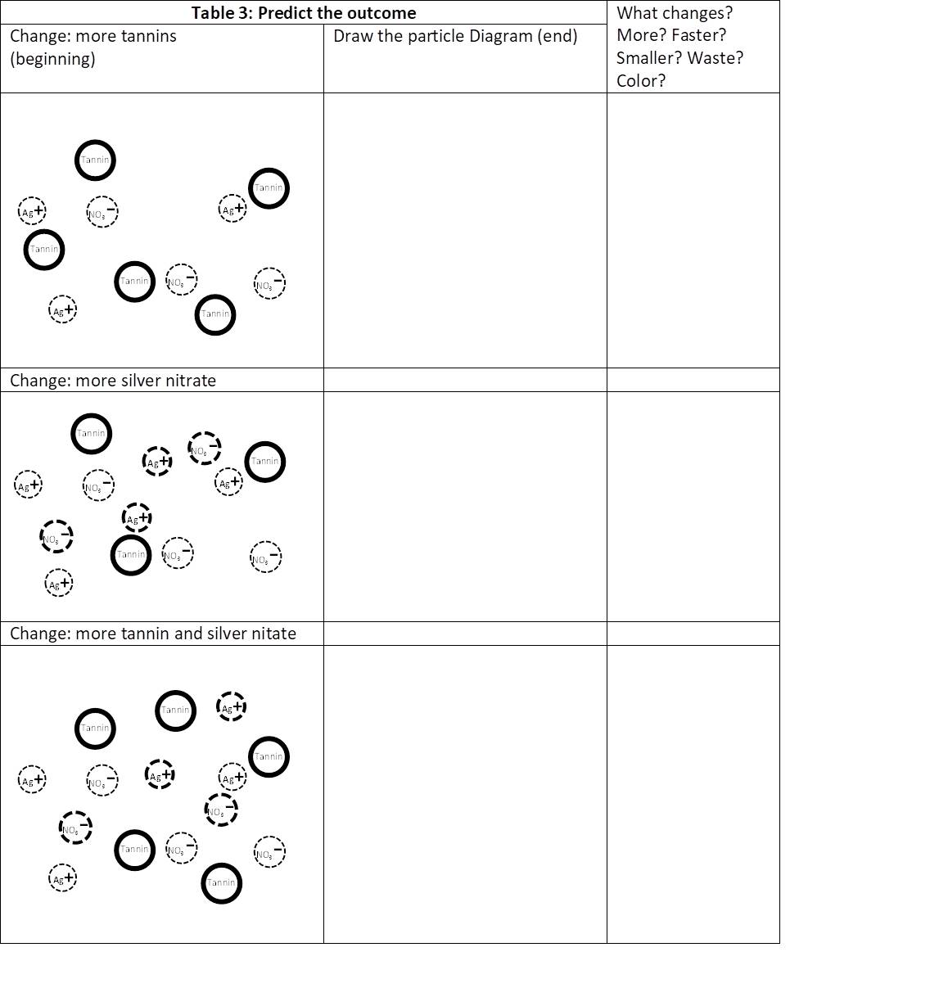
Changes? More silver nanoparticles at end.
Slower? Takes longer to make more silver?
Faster? More reactants means faster reaction?
Slower? Makes more acid?
Waste? No.
Color? Darker because more silver nanoparticles.
Smaller? Maybe, changing reactants.
Like “D” in figure 2, but with 2 extra silver nanoparticles, 2 extra nitrate ions, and 2 more acid particles.
Changes? More silver nitrate at end.
Faster? Unsure but maybe – changing reactants, Le Chatelier’s.
Waste? Yes, silver nitrate is going to be wasted.
Color? Probably same color, same amount of silver and tannins.
Smaller? Maybe, changing reactants.
Like “D” in figure 2, but with 2 extra unreacted Silver ions and 2 extra unreacted nitrate ions.
Changes? More tannin at end.
Faster? Maybe, changing reactants, Le Chatelier’s.
Waste? Yes, tannin is wasted, but maybe more silver nitrate reacts?
Color? Darker brown from tannin.
Size? Maybe, changing reactants.
The particle diagram will look like “D” in figure 2, but with 3 extra unreacted Tannin particles.

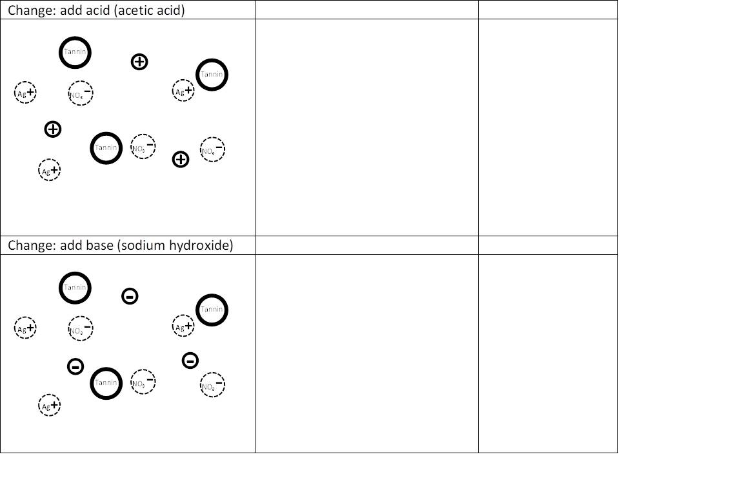
Changes? More acid at end.
Slower? Le Chatelier’s Principle – more acidic can’t self correct.
Waste? Acid.
Color? Lighter because smaller nanoparticles scatter light less.
Smaller? Slower reaction, smaller nanoparticles.
Like “D” in figure 2, but with 3 extra acid particles.
Like “D” in figure 2, but with either 3 extra base or no acid-base at all (acids neutralize bases)
Changes? More acid at end.
Faster? Le Chatelier’s Principle – more basic reactants self correct with acidic products.
Waste? None? Sodium Hydroxide?
Color? Darker because larger nanoparticles scatter more less.
Faster? faster reaction, larger nanoparticles.

10.0 Worksheet: Observation 3
- Group Choice to improve silver nanoparticle production: __Add sodium hydroxide____
- Do you think it will (circle all the answers that apply)
Produce more silver nanoparticles Produce the same amount Produce less

Produce silver nanoparticles faster Produce them same speed Produce them slower

Reduce Silver Nitrate waste Keep same waste Increase waste
And most importantly
Reduce silver nanoparticle size Produce the same size Produce larger size
Table 4: Effect of changing silver nanoparticle production
 | Test tube D  2 drops silver nitrate  2 drops tannic acid | Test tube E  2__ drops of silver nitrate  2__ drops of tannic acid  1__ drops of _sodium hydroxide____
Time | Record Observations
0 min | Slight brown tint. | Added sodium hydroxide first, then tannin. Turned darker almost instantly when the silver nitrate was added.
5 min | Slight brown tint | Darker brown- black.
10 min | A bit darker like before. Laser test shows silver nanoparticles. | Almost black. Reaction stopped? Too dark to see laser. But not getting darker.
15 min | Every time, slightly more dark brown. | Almost black. No change.
20 min | Every time, slightly more dark brown. | Almost black. No change.

10.1 Worksheet: Questions 3
Use the stereoscope to examine dried D and E samples. You are comparing the old process with your improved process. Use the information in table 4 along with everything you learned to answer questions 25-33.
- Did you produce more/less silver? Student could answer yes or no.
- How do you know?
No - There was no extra silver nitrate/tannins to make extra silver.
Yes – there was visible silver nitrate in the edge of D and no silver nitrate in E. More reacted.
Yes – The silver looks like larger individual pieces in E instead of thin dendrites in D. It looks like pebbles of silver. Visually looks like more.
- Did you produce silver faster/slower? Much faster.
- How do you know?
After 20 minutes, D was still changing colors. In less than 5 minutes E stayed black. The color change was apparent in E instantly.
- Did you waste more/less silver nitrate? Less.
- How do you know?
Less visible silver nitrate in the corners.
- Did you produce smaller/larger silver nanoparticles? Much larger.
- How do you know?
The color was a lot darker – black almost. Not from more tannins. Mostly not from more silver. Only option left over is darker because nanoparticles larger.
- Acting like a chemical engineer, what is you final recommendation to improve the creation of silver nanoparticles?
We recommend that a small amount of sodium hydroxide be added to the reactants.
- Concerning your recommendation, how will the manufacturing process be improved?
The manufacturing process will be much faster, like 20 times faster. The reaction is so fast, none of the silver nitrate is wasted – it all reacts. It is like the tannin was supercharged.
- Concerning your recommendation, are there any tradeoffs?
Yes, the silver nanoparticles are larger.

