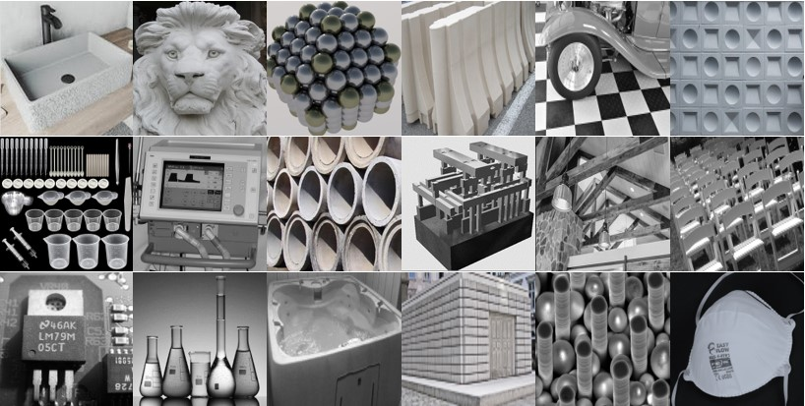
Design Engineering Student Worksheet

Using the 24 pictures above, answer the following for each picture:

- Identify the object’s name and plausible function.
- What is a probable size/scale for the object? Nano-, micro- or macro?
- Describe the shape and material composition of the parts in the objects.
- How are the parts consistently engineered?
- Define “model” and “prototype.”
- Is the object a model or a prototype?
- How does the design shape and materials support the function of the object?

