Volume Worksheet Answers

Calculating the Volume to Fill Engineered Objects Geometric Shapes

Prisms, cones and cylinders refer to 3-dimensional (3D) objects that an external (surface) walls that enclose an interior compartment. Often referred to by other names, a “box” is a square or rectangular prism and a “can” is a cylinder. The volume of the compartment depends on the external walls’ dimensions.

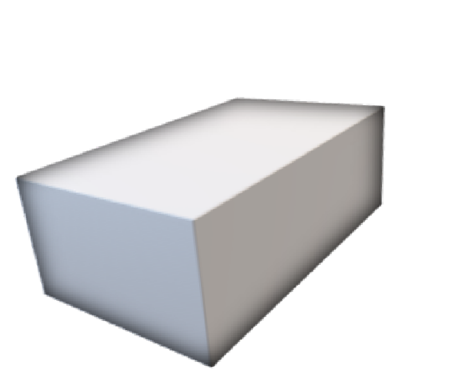
To simplify the prototype, use either square or rectangular prisms. Calculate the volume needed to fill prism without any objects added. Volume units are written cubed (ex. cubic centimeters written as cm³) or used a “liquid” unit (ex. milliliters). Object(s) added into the internal compartment will reduce the final resin volume as the object(s) takes the resin space.
Cuboid or Rectangular Prism  (Box; Ice Cooler) | - four sides (walls)  - flat sides  - 90° angle at edges  - space within walls | c c  b | Volume (V) = abc  If a=b=c then named Cube or Square. (b is similar to its height)  If two or no measurements equal then named Rectangle.
Triangular Prism | - three sides  - polyhedron with five faces  - right triangular prism has rectangular sides, otherwise called  oblique triangle | h a  c | V= (½ a)(c)(h) where base = (½ a)(c) and height=h
Cylinder (Paint can) | - Circular base exactly over each other with axis at right angles to base is “right  cylinder”  - If one base is displaced sideways call oblique cylinder | h  d | V = (base)(height) where base=(π)(radius²) & Radius = ½ diameter (d)  V=Base x height = π(r²)(h)

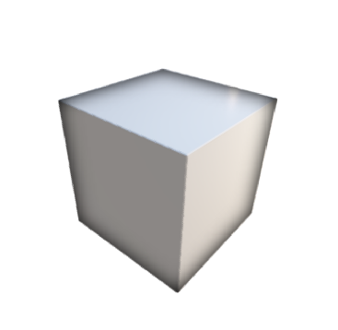

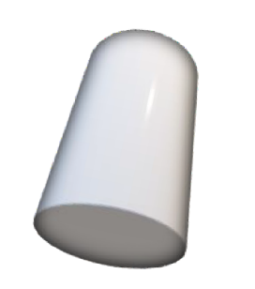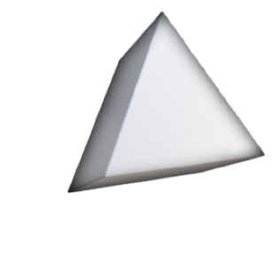

Calculate the Volume. π = 3.14

Section A. Paint Containers
- Sketch each can and label the canister’s base diameter and height. Calculate the maximum amount of paint that each paint canister can store.
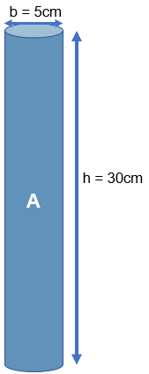
Can A: base diameter = 5cm
height = 30cm

Can B: base diameter = 10cm
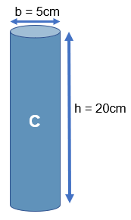
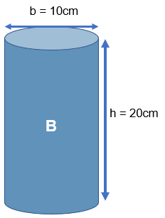
height = 20cm

Can C: base diameter = 5cm
height = 20cm

Can A: V = 588.75cm³
Can B: V = 1,570 cm³
Can C: V = 392.5 cm³

- What is the volume of a cylinder that has a radius of 3 in and a height of 6 in?

V = Base x height = π (r²)(h)= 3.14(3²)(6) = 169.56 in³

Section B. Boxes
- When preparing for a picnic, an ice cooler is to be filled with drinking water. Which cooler can hold the most water?

Cooler A: a = 40cm V = 64,000 cm³ Cooler A can hold the most water
b = 40 cm
c = 40cm

Cooler B: a = 25cm V = 32,000 cm³
b = 32cm
c = 40cm

- Calculate the volume of a cooler that has the dimensions of width 25 in, length 32 in and height 40 in. What is the volume in inches and centimeters?
V= a*b*c = 32,000 in³
Conversion factor is 1in = 2.54cm
V = 32,000 in³ x (2.54cm/in)³
V = 524,386 cm³

- What is the volume of a box with a base of 4 inches by 4 inches and a height of 10 inches?
V = Base x height = (4 x 4) (10) = 160 in³ (2622cm³)

- What is the volume of a box with a base of 8 inches by 8 inches that has a height of 10 inches?
V = Base x height = (8 x 8) (10) = 640 in³ (10488cm³)

Section C: Triangular Prism with 90-degree angle

- Calculate the volume of a right triangular prism with sides of 3in x 4in x 5in and a height of 12in.
V = Base x height = (1/2 bh) (H) = (1/2 x 3 x 4) (12) = 72 in³ (1180 cm³)

- Calculate the volume of a right triangular prism with sides of 3in x 4in x 5in and a height of 10in.
V = Base x height = (1/2 bh) (H) = (1/2 x 3 x 4) (10) = 60 in³ (983 cm³)

- Calculate the volume of a right triangular prism with sides of 5in x 12in x 13in and a height of 12in.
V = Base x height = (1/2 bh) (H) = (1/2 x 5 x 12) (12) = 360 in³ (5899 cm³)

