Onion Cell Lab Sheet Answer Key
Onion Cell Drawing
Key for drawing the onion cell parts

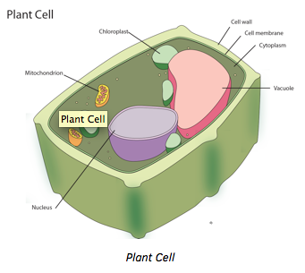

Draw an onion cell that best represents what you observed. Label its parts. Include a description of the function of each organelle you labeled.

Describe what you saw with each fluorescent tag. Did it help you get a better picture of the cell? Why or why not?
For the teacher: This is where the student will record their observations. Based on what they used, some may work, while others may not. Students need to answer the questions in complete sentences and answer each of the questions to their best ability.

- Cell Membrane - A lipid barrier that encloses the cytoplasm and controls what enters and exits the cell.
- Nucleus - A membrane-bound structure in eukaryotic cells that contains the DNA.
- Cytoplasm - The jelly-like material inside the outer membrane of a cell that holds the nucleus, organelles, and other components of the cell.
- Mitochondrion - An organelle in the cytoplasm of eukaryotic cells that functions in energy production, the power factory of the cell.
- Vacuole - A large, water filled organelle present in all plant and fungal cells and some animal and bacterial cells.
- Chloroplast - A membrane-bound organelle in plants that is the site of photosynthesis.
- Cell Wall - A tough, protective barrier that surrounds the outer membrane of some types of cells

Grading Rubric | Points | Points Earned
Cell drawing | 30 pts
Cell organelles | 5 pts per organelle (30 pts max)
Cell organelle functions | 5 pts per organelle (30 pts max)
Fluorescent dye description | 10 pts
Bonus: Use of color and neatness | +10 pts
Total

