Formative Assessment 1 Answer Key

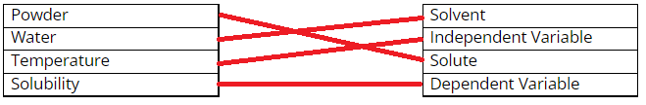
- Match the words to their role.

- If a solution is saturated that means _____.
  - The solution has no solute in it at all.
  - The solution does not have enough solute.
  - The solution has the maximum amount of solute it can hold.
  - The solution has more solute than it can hold.

- As heat increases solubility _____.
  - increases
  - decreases
  - stays the same
  - There’s not enough information to answer this question.

- As heat increases which of the following happens to electrons:
i. They speed up.
ii. Their energy increases.
iii. They get closer together.
  - i only
  - iii only
  - i and ii only
  - i, ii, and iii

- The solution you created is classified as an ______.
  - element
  - compound
  - homogenous mixture
  - heterogeneous mixture

