Crystal Creator Worksheet

- What type of crystal did your team grow?

______% alum and ______% chrome alum

- Fill in the resistance measurements for the following: temperatures going up from 20 degrees to 90 degrees in 5 degree increments and then temperatures coming back down from 90 degrees to 20 degrees in 5 degree increments.

Temperature  (20 to 90 deg) | Resistance  (ohms) | Temperature  (90 to 20 deg) | Resistance  (ohms)
20 |  | 90
25 |  | 85
30 |  | 80
35 |  | 75
40 |  | 70
45 |  | 65
50 |  | 60
55 |  | 55
60 |  | 50
65 |  | 45
70 |  | 40
75 |  | 35
80 |  | 30
85 |  | 25
90 |  | 20

- Graph your temperature vs. resistance data.

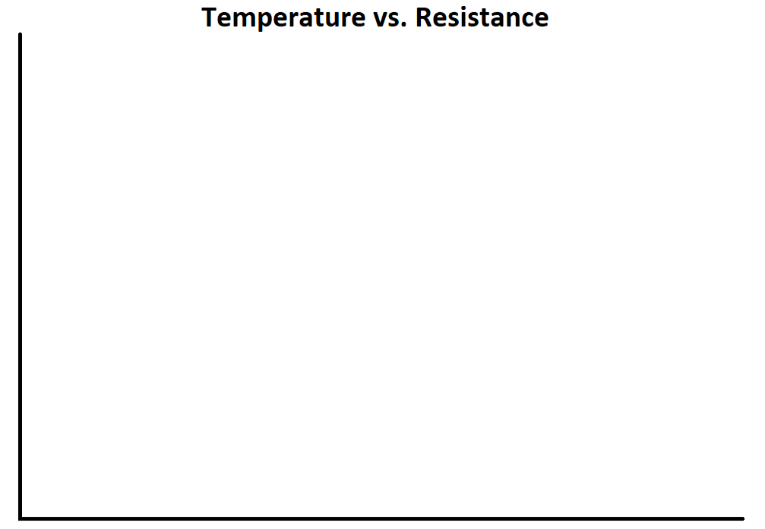

- What relationship does temperature have with resistance? Why do you think that relationship exists?

- Hypothesize: What do you think you should change to decrease the resistance of your crystal? Why?

