Design Planning Worksheet Answer Key

Plastics have become an essential part of our daily lives, but they pose significant environmental and health challenges. They pollute oceans, take a long time to decompose, and harm wildlife. Additionally, plastics can affect human health through the food chain, drinking water contamination, and the release of toxic chemicals.

What are your thoughts?
Briefly answer in your own words.
How might plastics affect human health?

Potential Answers: Plastics can affect human health through the chemicals they contain, such as BPA and phthalates, which may leach into food or water and disrupt hormones. Microplastics can also enter the body through air, food, or water, and researchers are still studying their long-term health effects.

Design Your Filter
In the space below, document your initial design choices for your filter. Be sure to include a labeled diagram representing your design and briefly explain the material choices and placement.
Draw and label filter here.  Answers will vary.  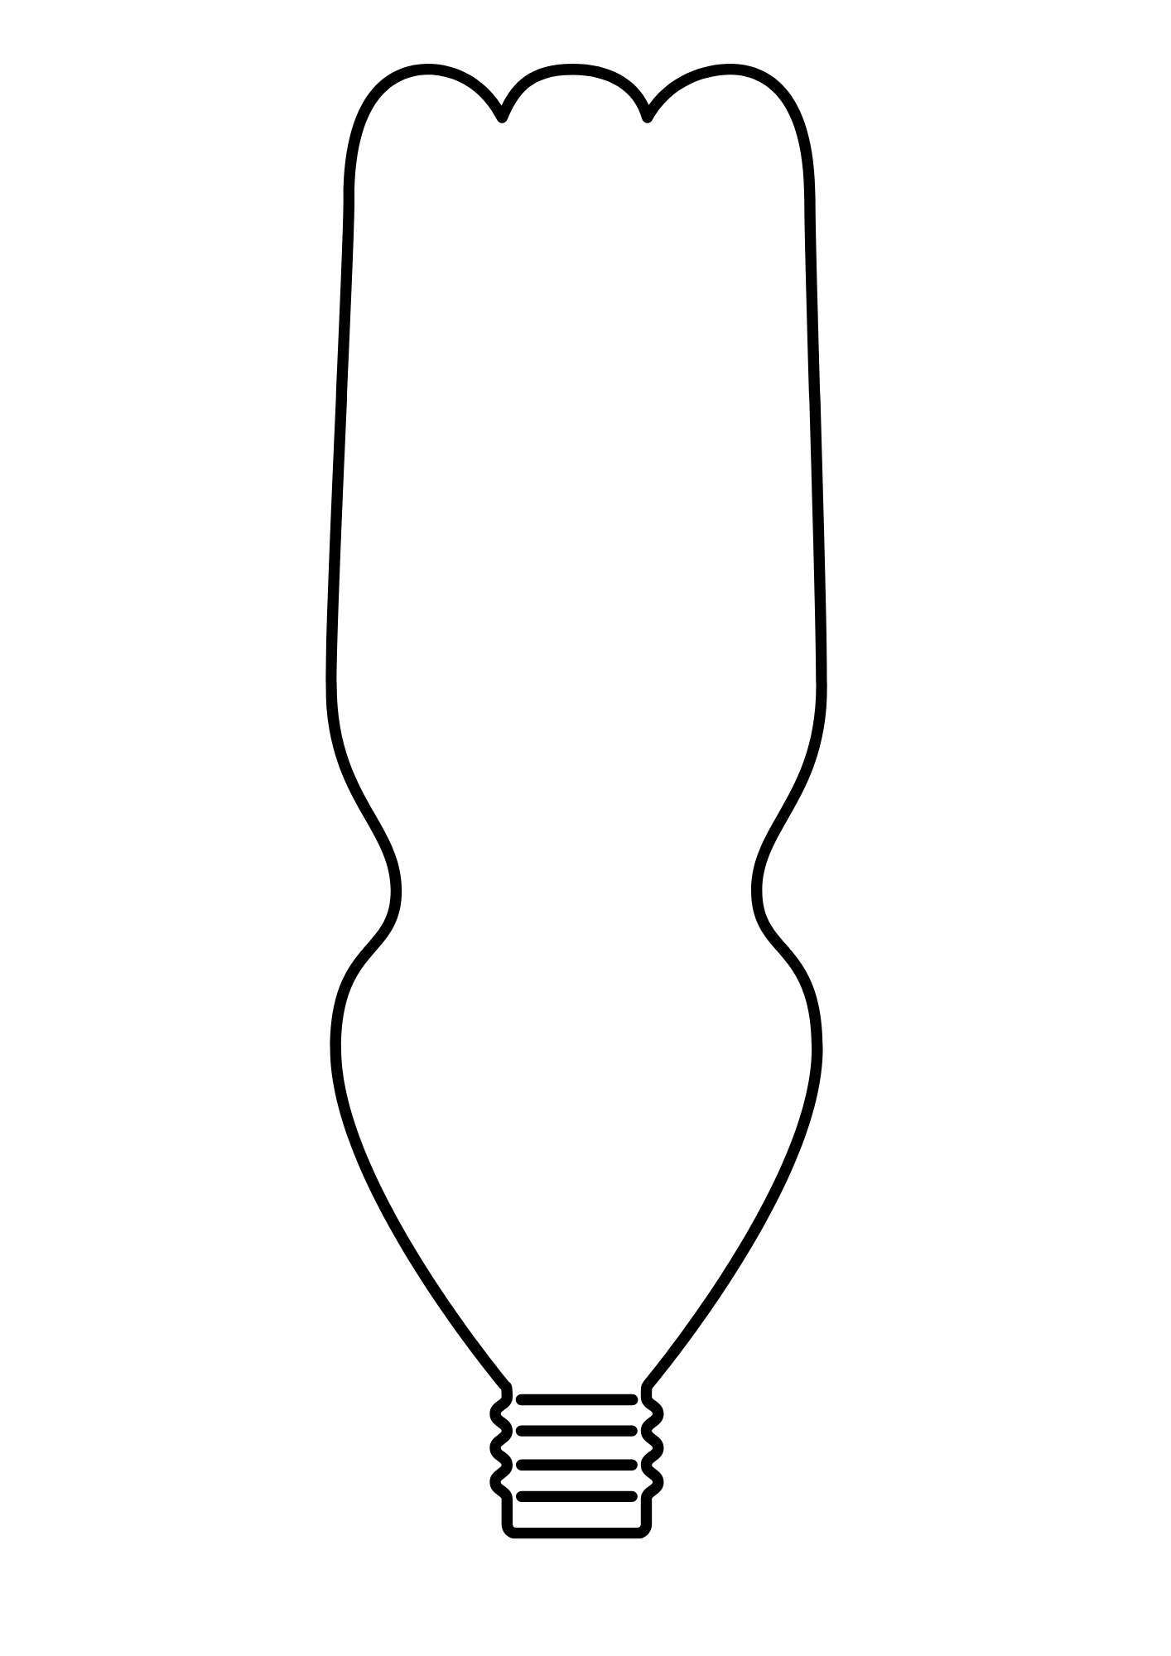 | Explain why you chose each material and why you placed it where it is in the filter.  Answers will vary.

Make sure you wear googles, gloves, and an apron when handling the materials!
Build Your Filter Designate a person in your group to retrieve the materials your group needs to create and test your filter.
Test Your Filter
As a group, test your filter using the plastic solution provided by making observations, capturing the water sample after it flows through the filter, and testing the sample to see how it compares to the initial sample under the microscope.
- Describe your initial observations and hypotheses.  Answers will vary. | - Describe how the plastic and water solution looks before running it through your filter.  Answers will vary.
- Describe how the plastic and water solution looks after running it through the filter.  Answers will vary. | - Describe how effective you feel your filter was at removing the plastic from the water.  Answers will vary.

Improve Your Filter
Answer the following question as if we had significantly more time and if you could acquire any material you feel your filter could benefit from.
What improvements would you make if you could redesign and remake your filter, and why?
Answers will vary.

Final Thoughts
Answer these questions.
What are microplastics?

Potential answers: Microplastics are tiny plastic particles less than 5 millimeters in size. They come from the breakdown of larger plastic items or are manufactured small for use in products like cosmetics or cleaning supplies. Microplastics are found in oceans, soil, air, food, and water, and they can enter the bodies of humans and animals, raising concerns about their impact on health and the environment.

Why might particle size be important in filtration?

Potential answers: Particle size is important in filtration because it determines whether a substance can pass through a filter or not. Filters are designed with specific pore sizes to block particles above a certain size while allowing smaller ones to pass through. Smaller particles can slip through filters more easily, while larger particles get trapped. This is crucial for processes like water purification, air filtration, and even medical applications, where removing harmful of unwanted particles is essential for safety and effectiveness.

Return all materials to the front and tidy up your space!

