Design Planning Worksheet

Plastics have become an essential part of our daily lives, but they pose significant environmental and health challenges. They pollute oceans, take a long time to decompose, and harm wildlife. Additionally, plastics can affect human health through the food chain, drinking water contamination, and the release of toxic chemicals.

What are your thoughts?
Briefly answer in your own words.
How might plastics affect human health?

Design Your Filter
In the space below, document your initial design choices for your filter. Be sure to include a labeled diagram representing your design and briefly explain the material choices and placement.
Draw and label filter here  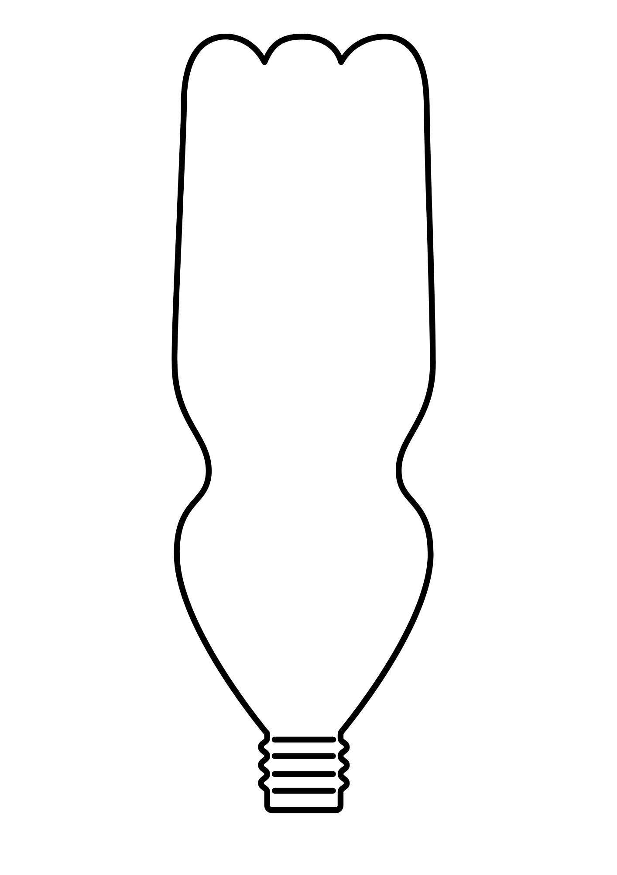 | Explain why you chose each material and why you placed it where it is in the filter.
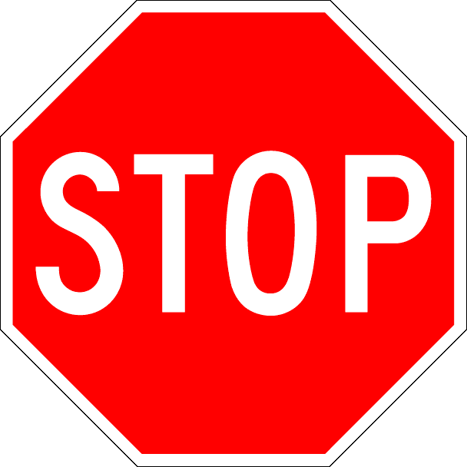
Make sure you wear googles, gloves, and an apron when handling the materials!
Build Your Filter Designate a person in your group to retrieve the materials your group needs to create and test your filter.

Test Your Filter
As a group, test your filter using the plastic solution provided by making observations, capturing the water sample after it flows through the filter, and testing the sample to see how it compares to the initial sample under the microscope.
- Describe your initial observations and hypotheses. | - Describe how the plastic and water solution looks before running it through your filter.
- Describe how the plastic and water solution looks after running it through the filter. | - Describe how effective you feel your filter was at removing the plastic from the water.

Improve Your Filter
Answer the following question as if we had significantly more time and if you could acquire any material you feel your filter could benefit from.
What improvements would you make if you could redesign and remake your filter, and why?

Final Thoughts
Answer these questions.
What are microplastics?

Why might particle size be important in filtration?

Return all materials to the front and tidy up your space!

