Activity Worksheet
Challenge
Use the materials provided to formulate a sustainable, cost-effective multipurpose cleaning product.

Step 1: Understand and Test Your Materials
Using the information provided, review the ingredients provided and document your observations about each.
Ingredient | Properties (e.g., texture, smell, reaction with water) | Hypothesized  Cleaning Use | Biodegradable?  Yes or No
Sodium Bicarbonate

Citric Acid

Essential Oils

Isopropyl Alcohol

Vinegar

Step 2: Experiment With Mixtures
Test combinations:
  - Using the cups provided, mix small amounts of the ingredients and observe reactions.
  - Record results for foam, solubility, cleaning power, or other effects. Circle Yes or No.
  - Test on a small area, such as your working table.

Combination Tested | Dissolves | Foams | Cleans
Vinegar + Sodium Bicarbonate | Yes No | Yes No | Yes No
Vinegar + Citric Acid | Yes No | Yes No | Yes No
Alcohol + Essential Oil | Yes No | Yes No | Yes No
Alcohol + Sodium Bicarbonate | Yes No | Yes No | Yes No
Alcohol + Citric Acid | Yes No | Yes No | Yes No
Other: _________________ | Yes No | Yes No | Yes No

Step 3: Imagine and Plan Your Product

- What type of cleaner will you design?

- Based on your research and your mixtures observations, what natural, nontoxic ingredients will you use? List each ingredient you will use and why you chose each ingredient.

- Predict how you think your cleaning formula will work.

Step 4: Create and Test Your Product
Create your product:
  - Using the cups provided, mix small amounts of the ingredients you chose.

Test your product:
  - Record results of your product for foam, solubility, cleaning power, or other effects. Circle Yes or No in the table below.
  - Test on a small area, such as your working table.
  - Run your test at least twice.

Combination Tested | Dissolves | Foams | Cleans
 | Yes No | Yes No | Yes No
 | Yes No | Yes No | Yes No
 | Yes No | Yes No | Yes No

- What worked?

- What did not work?

- What will you change to improve your product?
(Optional) Step 5: Improve Your Product
Improve your product:
  - Using the cups provided, mix small amounts of the ingredients you chose to improve your product.

Test your improved product:
  - Record results of your product for foam, solubility, cleaning power, or other effects. Circle Yes or No in the table below.
  - Test on a small area, such as your working table.
  - Run your test at least twice.

Combination Tested | Dissolves | Foams | Cleans
 | Yes No | Yes No | Yes No
 | Yes No | Yes No | Yes No
 | Yes No | Yes No | Yes No

- What worked?

- What did not work?

- What would you change to improve your product?

Step 6: Final Product Test
- Test your final cleaner on your worktable surface, or the teacher may provide trays or plates with ketchup to ensure consistent testing conditions. Evaluate the following:
  - Cleaning ability

  - Scent

  - Residue

  - Ease of application

Step 7: Market Your Product
- Product Name:

- Recipe:
  - List the ingredients and their amounts. Use the price list below.
Ingredient | Amount | Cost
Water | 1 bottle | 1.00
Spray Bottle | 1 bottle | 4.00
Total Cost

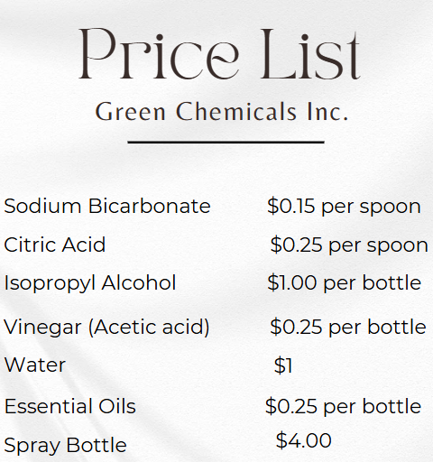

Step 8: Create a Label
Design a label for your cleaning product. Sketch your label below, including Product Name, Main Ingredients, Safety Warnings, Benefits (e.g., eco-friendly, child-safe, nontoxic)
Draw your label here

Once your label is complete, use the markers and labels provided to draw your final label for your spray bottle.

Step 9: Present Your Product
Prepare a three-minute presentation covering:
- The name and purpose of your product.
- Key ingredients and why you chose them.
- Cost analysis (why it’s affordable).
- Demonstration (if possible).

Step 10: Reflection Questions
- What surprised you most about how the ingredients worked? ______________________________________________________________________
__________________________________________________________________________________________________________________________________________________________________________________________________________________

- How could you improve your product?
______________________________________________________________________
__________________________________________________________________________________________________________________________________________________________________________________________________________________

- What did you learn about designing eco-friendly products?
______________________________________________________________________
__________________________________________________________________________________________________________________________________________________________________________________________________________________

