Teacher Notes

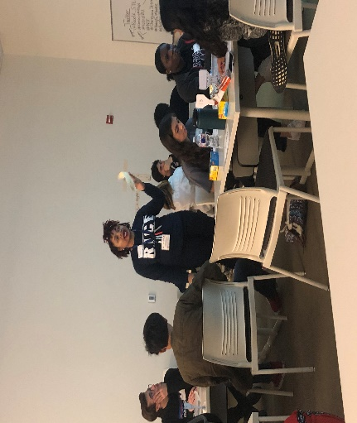
State STEM Standards The student examines the relationship of biotechnology to the development of commercial products. The student is expected to design an environmentally friendly, biodegradable potato chip bag.
ITEEA Standards Provide a common set of developmentally appropriate expectations in the study of technology, including the engineering design process.
NGSS Standards Design a solution to a complex real-world problem, based on scientific knowledge, student-generated sources of evidence, prioritized criteria, and tradeoff considerations.

LESSON:
In an attempt to reduce plastic pollution in the environment, students will engineer a high quality, potato chip bag that should pass the quality control test. First things first, ask the students how much plastic they use in their everyday routines (Students will name different items, storage containers, grocery bags, water bottles, etc.…).
The Biodegradable Husk-Bags is made from corn husk (tamales) and students are engineering a prototype that will hold potato chips without damaging the product.
Teacher will use instructional, interactive PowerPoint provided to help guide the lesson.
Students will plot the data provided on the student hand out to demonstrate the epidemic of plastic pollution. The excessive use of plastic has harmed marine life substantially and our environment. Plastic does not degrade and it is found in our oceans.

You Do The Math:
Graph the data table below of consumers who purchased bags of Lay’s potato chips.
Year | # Lay’s bags sold  (millions)
2014 | 27.59
2015 | 35.44
2016 | 32.09
2017 | 32.74
2018 | 34.62
2019 | 35.22

In six years, how many bags of Lay’s potato chips were sold? 197,700,000 million bags
Discussion:
Ask the students how many bags of chips did they eat this week? Month? Calculate the total for the entire room.

This is just one brand, Lay’s. How do you think other brands (Ruffles, Zapp’s, etc…) will affect this number?

Comic strip: Students will read comic strip (student handout) to help understand the environmental issue. This will also help students to see the need for the Biodegradable Husk-Bags.
Students will use materials, corn husk, organic glue, scissors, timer, empty potato chip bags (for control), kitchen scales, permanent markers and bowls of water to start designing a Biodegradable Husk-Bags.
Graph: Students will plot the data by putting the year on the x-axis and the number of bags sold on the y-axis. Students will show a trend line using the data.
This will be a great opportunity to teach students how to graph and how to plot points. Teacher can also speak about independent and dependent variables. The independent variable is on the x-axis and the dependent variable is on the y-axis.

Videos: Plastic Pollutants Video Show this video first. This will follow after the students plot the graph.
Students will use the rubric below to start their design. Students will shake bag 20 times. If the bag bust on shake 17 then the student will divide 17/20= 85%. The student will do this for each run.

Quality Control Test:
TEST | Run 1 | Run 2 | Run 3 | % Score | Passed (100%) | Failed (<100%)

Weigh your bag (1.5 to 2.0 ounces).
Shake (left, right and up down) Count as you shake. | 20 | 20 | 20
Toss (5ft: 10Xs) | 10 | 10 | 10
Drop at height (from waist, arm, above head). Is it intact? | Yes  No | Yes  No | Yes  No
Temp under a heat lamp:
1 min, 3 min 5 min
Tensile strength  1 golf ball 33%  2 golf balls 66%  3 golf balls 100% |  |  |  | Add up % and divide by 3.  This is the score.
Moisture: Are the contents wet dry? | Yes  No | Yes  No | Yes  No

Shake the prototype 10 times in a left to right motion; up and down 10 times.
Toss the bag up in the air about 5 feet 10 times (catch the bag).
Drop the bag from waist height, arm height and above your head.
Moisture Submerge the prototype in the pan of water and count to ten.
Tensile Strength Place as many pebbles or rocks on outside of prototype.
Temperature Place prototype under heat lamp (1 min, 3 min, 5 min).

Students’ prototypes will vary. Students will complete quality control tests. The team that designs that best Biodegradable Husk-Bags wins.
Note: Students may want to use organic glue to make the entire bag 100% biodegradable. 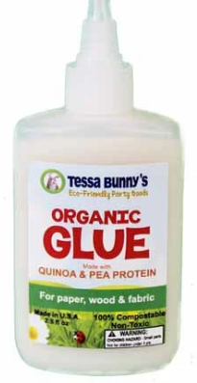
Extension Optional: Students can create their own glue by mixing:
3 Tablespoons of Gum Arabic
1-2 Tablespoons of vegetable glycerin
½ teaspoon of water
Combine ingredients and keep stirring until it becomes sticky and gummy. Let sit for a minute. Then stir vigorously. Glue should be ready for use.

Closure: Think, Pair & Share
- What worked? What didn’t? Students will share design successes/struggles.
- How can we apply this to the real world? This can limit the massive production of potato chip bags (answers may vary).
- Do you care about plastic pollution? Explain.
- What changes can you make to help eliminate the use of plastic? Students will say drinking from a canteen, bringing a non-plastic bag to the grocery store, use silverware and not plastic utensils (answers may vary).
- Students will complete consumer/peer review survey to leave feedback on peer’s bag design. The teacher can assign the bags a number and let the student judge pull a random number to review a bag.

