Pre-Activity Discussion Questions

- What gives power to your cell phone?

- What happens when you ‘discharge’ a battery?

- How are batteries used today?

- Are there different kinds of batteries? If so, give some examples.

- What do you think are the differences between these types of batteries?

- What are the differences between AA, AAA, etc. types of cells as shown in Figure 1?

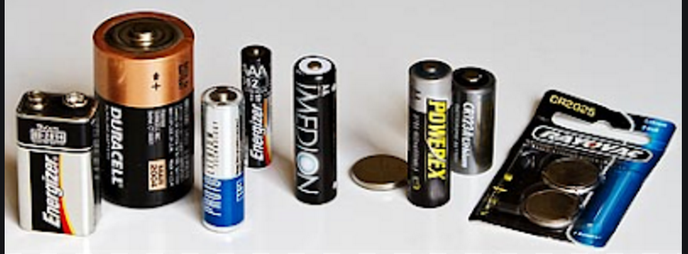
Figure 1: Batteries of various styles and voltage.

