Build a Binary Trumpet
Have you ever played an instrument using a computer? Today, you’ll act as if you are engineers and explore the components that go into making a computer-based trumpet. Our goal is to hold a class concert with each group performing a song using the digital trumpet they built. In your teams, you’ll be electrical engineers responsible for wiring up a “binary trumpet” and experimenting with the binary number system to create a short song. Let’s get started!
- Get to know your breadboard.
Breadboards enable electrical engineers to easily connect wires together without soldering them.
That way, they can test many different circuits. Photo 1 shows which rows are connected in a breadboard. If you place wires in different (unconnected) rows, they will not be connected.
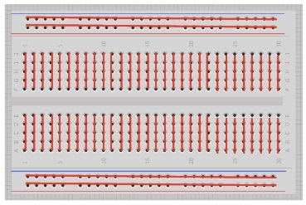

Photo 1. Breadboards connect wires in the same rows.
- Place a button in the breadboard.
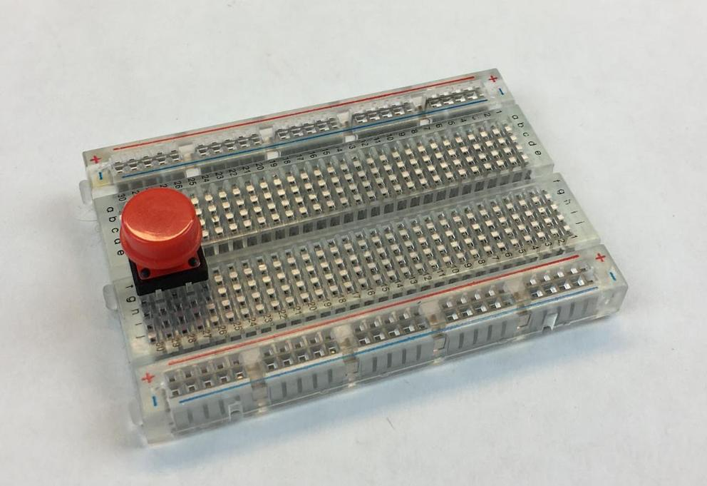
The pushbuttons are designed to plug into a breadboard. Notice that a button has two pairs of legs—one pair on each side of the button. You will only use one pair of button legs for your circuit. Plug the red button into your breadboard so that one pair of legs is on each side of the gap in the middle of the breadboard (see Photo 2).

Photo 2. Place a button into the breadboard as specified.

- Wiring a button.
Now that the button is plugged into the breadboard, use jumper wires to wire it to your MaKey MaKey. Jumper wires have a stiff metal pin on each end so that they are easy to plug into a breadboard. To connect the jumper wire to the MaKey MaKey, flip the MaKey MaKey over and plug the metal pin into one of the black plastic holes called a header.
Using two jumper wires, hook up your button by following the Photo 3 wiring diagram. Wiring diagrams show you how to connect the parts in a circuit. In the diagram, each colored line is a wire. Make sure you plug each wire into the correct breadboard row. If the pin is not in the same row as one leg of the button, then the circuit will not work!
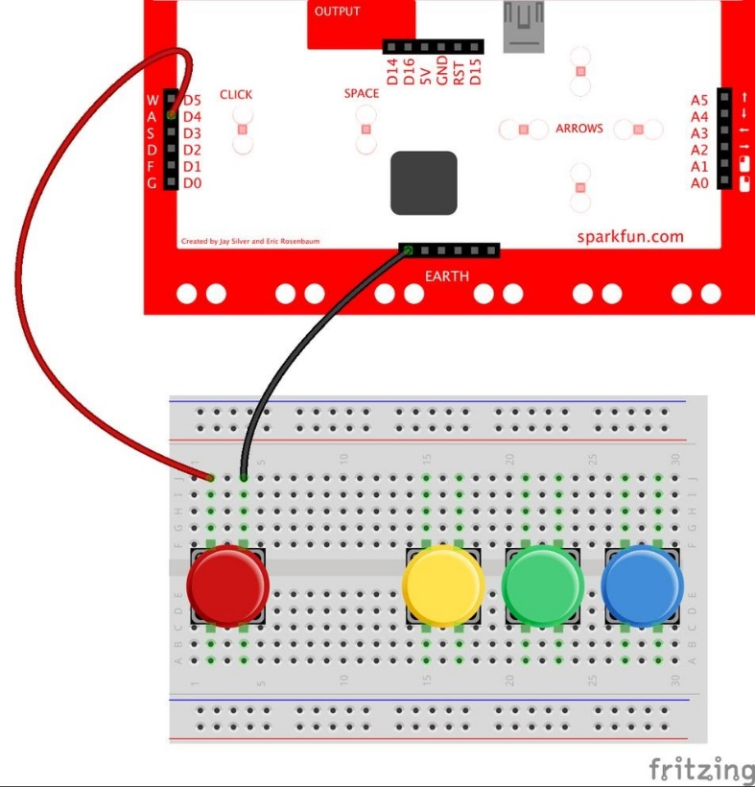

Photo 3. The wiring diagram for a single button.

- Wire the rest of your buttons.
Next, wire the other three buttons by following the Photo 4 wiring diagram below. One wire from each button connects to the header for “a, d, f or g” on the back of the MaKey MaKey. The other wire from each button goes to the headers above “earth.”
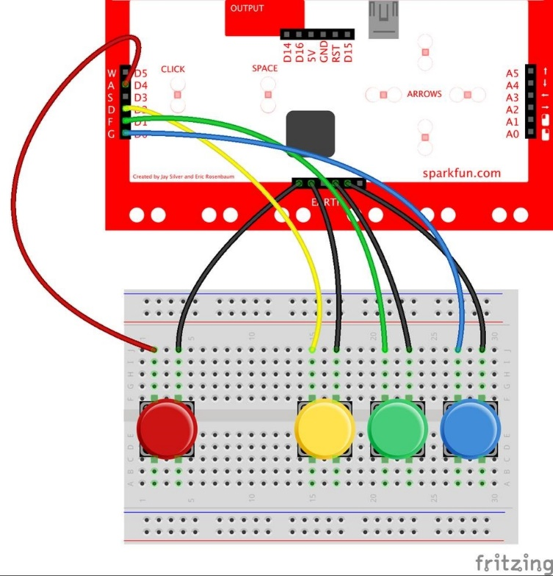

Photo 4. Wiring diagram for multiple buttons.
- Hook up the MaKey MaKey.
Use a USB cable to plug your MaKey MaKey into your computer.
Congratulations, you have finished wiring the binary trumpet!
- Load the binary trumpet Scratch program.
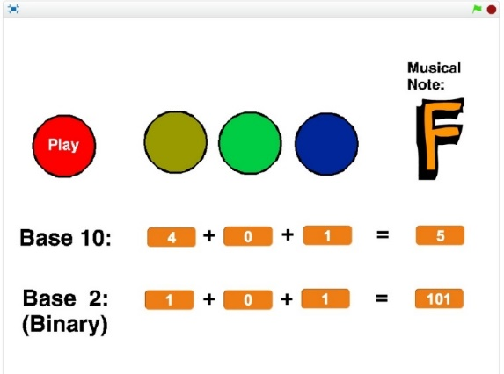
Next, open the binary trumpet program at: https://scratch.mit.edu/projects/132120896/. The screen should look like Photo 5. If the MaKey MaKey and circuit are connected correctly, when you press a button, one of the buttons on the screen goes dark. You should also see the numbers and musical letter change. Test to make sure that all four buttons are working correctly.

Photo 5. The binary trumpet Scratch program.

- Get to know the binary number system.
The binary number system is a way to write numbers using only zeroes and ones. The number system that we are most familiar with is called the “base 10” number system. The base 10 number 2 is expressed as “10” in binary.
- Counting binary on your hands.
Use the keys to count up from 0 to 7 by pressing the right combination of keys. The program shows you the value of each key in base 10 and binary. On the right side of the screen, notice the total number represented by the combination of keys. Fill in the table below with the binary version of numbers 0 to 7, then see how fast you can press the keys to count from 0 to 7.
Base 10 | Binary/Base 2
0
1
2
3
4
5
6
7
- Playing the binary trumpet.
Try pressing the red button. You should hear a musical note. Pressing different keys changes the note.
Congratulations! You’ve built your own electronic instrument.
Now it’s time to create a song for the class concert!

