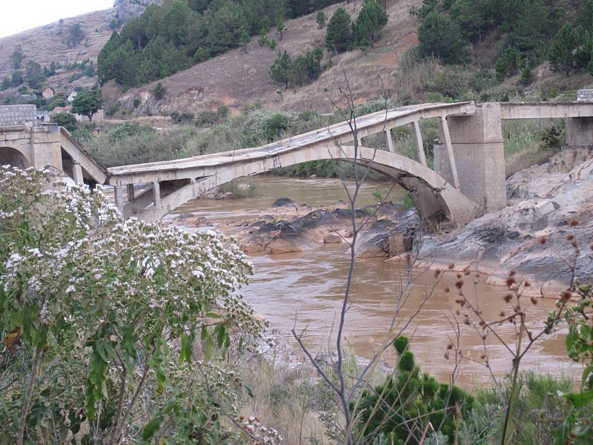**Operation Build a Bridge and Get over It**

**AFRICA**

*Image source*: 2011 NH53, Wikimedia Commons https://commons.wikimedia.org/wiki/File:Broken_bridge,_Madagascar.jpg

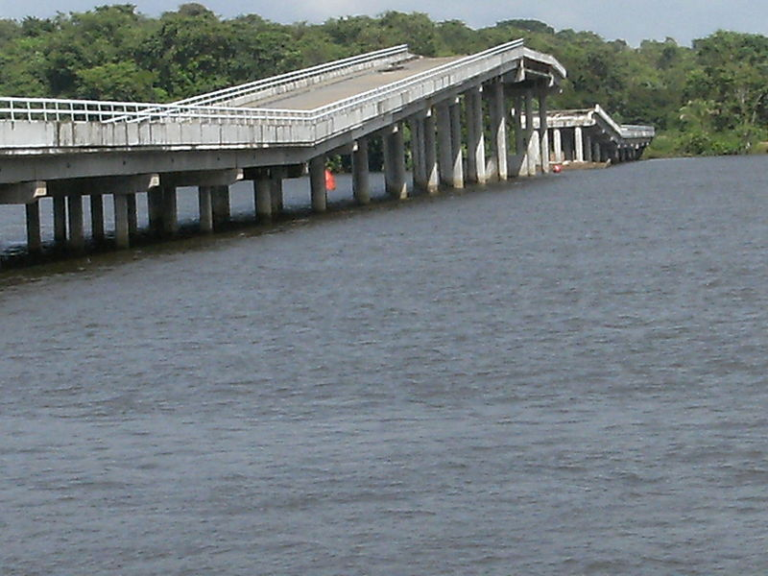

**South  
AmericA**

*Image source*: 2008 Mark Ahsmann, Wikimedia Commons https://commons.wikimedia.org/wiki/File:Broken_down_bridge_over_Suriname_river_between_Carolina_and_Jodensavanne_2.JPG

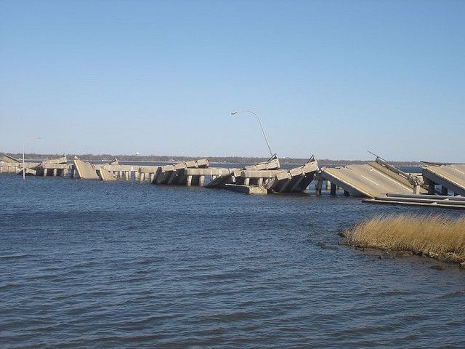

**Mississippi**

*Image source*: 2006 Klobetime, Wikimedia Commons https://commons.wikimedia.org/wiki/File:Ocean_Springs_bridge_six_months_after_Hurricane_Katrina.jpg

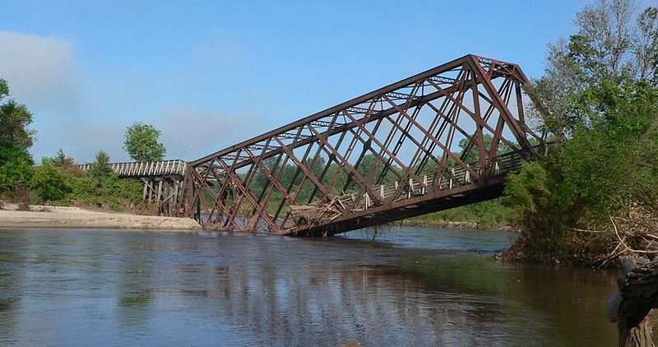

**Nebraska**

*Image source*: 2010 Ammodramus, Wikimedia Commons https://commons.wikimedia.org/wiki/File:Cowboy_Trail_Norfolk_Elkhorn_River_xing_damaged_3.JPG

**C O N F I D E N T I A L**